CHRISTIAN ANDREWS REPORT

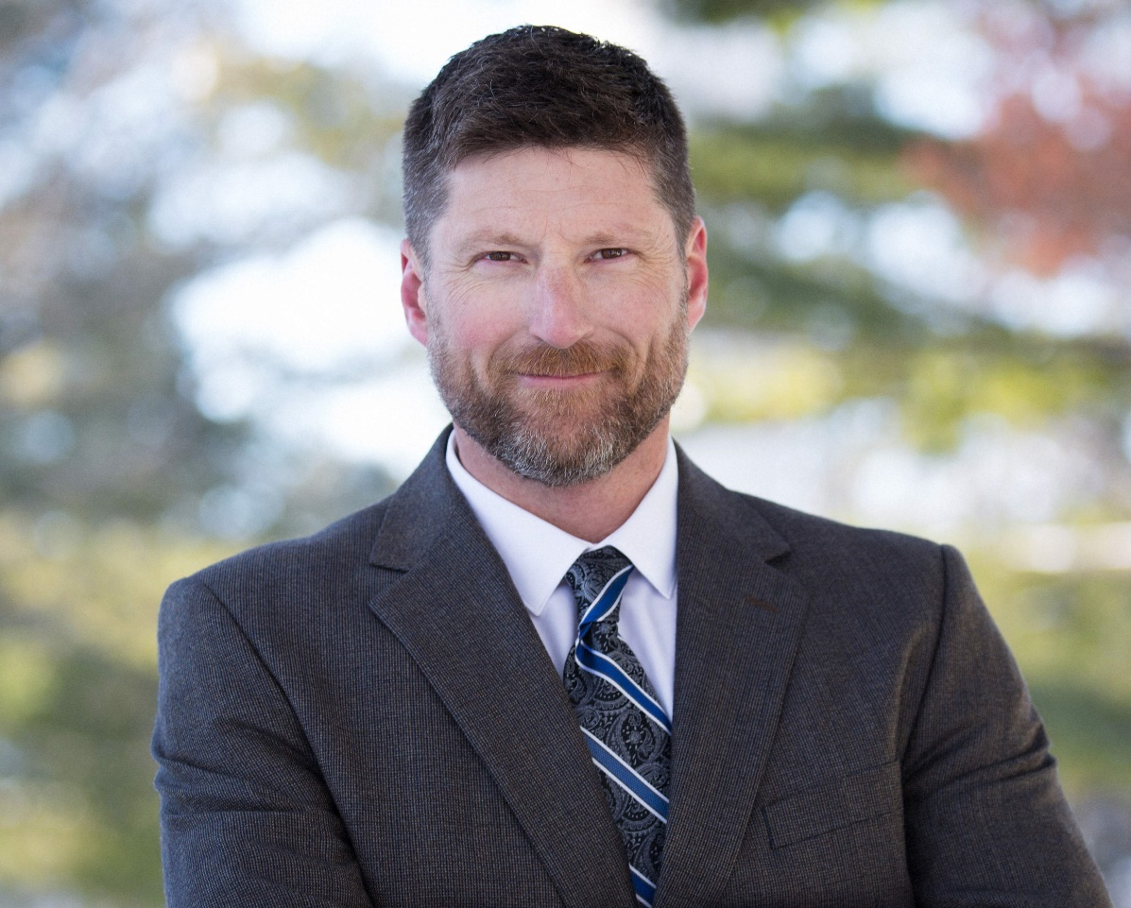

CASCADE STRATEGIES – JULY 2020

TABLE OF CONTENTS

BIOGRAPHY 3
TIMELINE 4
SMALL BUSINESS 5
PARTISAN POLITICS 8
RIGHT TO WORK 9
EDUCATION 10
ENVIRONMENT 11
TAXES 12
HEALTH CARE 14
MARIJUANA 15
SECOND AMENDMENT 16

BIOGRAPHY

Name: Christian Miles Andrews

Birth: Nov. 28, 1973

Residence: 610 5th Avenue Northwest
Mount Vernon, IA 52314

Family: Wife, Anna Mariah; Daughter, Sophia; Son, Gus

Education: Attended University of Northern Iowa, Did not graduate

Military: None

Professional Experience: Public works department, City of Mount Vernon

Political Experience: None

TIMELINE

Nov. 28, 1973 Born

1992 Graduated from high school

Late 1990s Moved to Kansas City

Dec. 17, 1999 Married Mariah Betz

2006 Moved to Iowa

2007 Started Good Wood Construction

2013 Moved to Mount Vernon

2014 Began working for City of Mount Vernon in public works department

SMALL BUSINESS

- Christian Andrews says that he owned a small business in Cedar Falls, Iowa, which , specialized in remodeling and carpentry work

  - According to Christian Andrews’ campaign website, “I’ve always enjoyed helping people and that’s why I do the work that I do. I can speak for regular Iowans because that’s who I am. I’ve been a truck driver, a carpenter, a small business owner, an activist and a stay-at-home dad. I’ve always had the ability to talk to anyone, whether you’re a CEO or steelworker.”

  - According to the Iowa House Democrats website, “Prior to moving to Mount Vernon, Andrews owned a small business in Cedar Falls, Iowa, specializing in remodeling and carpentry work. He and his wife and partner of 24 years, Mariah Andrews, helped to found the education advocacy group Unify for Education, to encourage the Iowa state legislature and Iowa Board of Regents to institute a public comment period during Regents’ meetings.”

- On LinkedIn, Christian Andrews is listed as sole proprietor owner of Good Wood Construction in Cedar Falls, Iowa

  - According to Christian Andrews’ LinkedIn profile, Andrews says that he was a Sole Proprietor Owner at Good Wood Construction.

- In Iowa, a trade name filing must be made by any person (sole proprietorship) or partnership engaged in business under a name different from their own true surname

  - According to the Iowa Secretary of State’s office, “A trade name filing must be made by any person (sole proprietorship) or partnership engaged in business under a name different from their own true surname. A trade name essentially informs the public ‘who’ they are doing business with but registering does not create any proprietary rights in the name. Corporations or limited liability companies organized in this state or authorized to do business in this state do not file for a trade name. All other trade names are filed with the county recorder in the county where the business is located.”

- According to the Black Hawk County recorder’s office, no trade name for Good Wood or for Christian Andrews was found on file in the county

Editor’s Note: On Aug. 29, 2018, a phone call was placed to the Black Hawk County Recorder of Deeds office. A search was done by three separate individuals from the office for a trade name for “Good Wood” or Christian Andrews. According to the recorder’s office, no records were found in Black Hawk County for a trade name for either of these search terms. No documentation for this was available, as no records were found with Black Hawk County.

- Iowa Code: “It shall be Unlawful for any person or co-partnership to engage in or conduct a business under any trade name, or any assumed name of any character other than the true surname of each person or persons owning or having any interest in such business unless such person or persons shall first record with the county recorder of the county in which the business is to be conducted a verified statement showing the name, post office address, and residence address of each person owning or having any interest in the business, and the address where the business is to be conducted”

  - According to Iowa trade name laws, as accessed through the Black Hawk County Recorder’s office, “Section 547-1 Use of Trade Name-Verified statement required. It shall be Unlawful for any person or co-partnership to engage in or conduct a business under any trade name, or any assumed name of any character other than the true surname of each person or persons owning or having any interest in such business unless such person or persons shall first record with the county recorder of the county in which the business is to be conducted a verified statement showing the name, post office address, and residence address of each person owning or having any interest in the business, and the address where the business is to be conducted.”

- Iowa Code: “Any person violating the provisions of this chapter shall, upon conviction, be punishable by a fine of not less than $25 nor more than $100 or by imprisonment in the county jail for a term not exceeding 30 days”

  - According to Iowa trade name laws, as accessed through the Black Hawk County Recorder’s office, “Section 547-4 Penalty: Any person violating the provisions of this chapter shall, upon conviction, be punishable by a fine of not less than$25 nor more than $100 or by imprisonment in the county jail for a term not exceeding 30 days.”

- No business named “Good Wood” has been registered with the Iowa Secretary of State’s office

  - According to the Iowa’s Secretary of State’s office, no business named “Good Wood” appears to have ever been registered with the state.

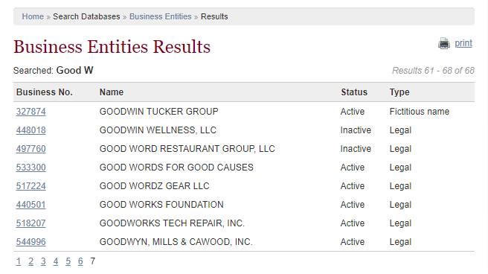

PARTISAN POLITICS

- In 2019, Christian Andrews wrote regarding Kim Reynolds, “Why did we elect this, (fill in the blank) Governor of Iowa? Wow. I can’t find anything nice to say about her.”

  - In a May 26, 2019, Facebook post, Christian Andrews wrote, “Why did we elect this, (fill in the blank) Governor of Iowa? Wow. I can’t find anything nice to say about her.”

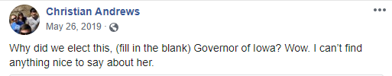

- In 2018, Christian Andrews called Andrew Yang, U.S. Sen. Jeff Merkley, South Bend Mayor Pete Buttigieg and Rep. Eric Swalwell, “four brilliant leaders and champions of people”

  - In a Dec. 23, 2018, article, the Des Moines Register reported, “A diverse lineup of candidates - both declared and potential - took the stage at Progress Iowa’s annual holiday party in Des Moines Thursday in a preview of what is likely to come during the 14 months leading up to Iowa’s first-in-the-nation caucuses.

“The lineup included Andrew Yang, a California entrepreneur; U.S. Sen. Jeff Merkley of Oregon; South Bend, Ind. Mayor Pete Buttigieg; and U.S. Rep. Eric Swalwell of California.

“Yang has formally declared his candidacy. Merkley, Buttigieg and Swalwell all are actively considering a run.”

  - According to the same article, “‘I’m not quite ready for the presidential race to be here, but I’ll tell you what - we had four really good people up there: four brilliant leaders and champions of people,’ said Christian Andrews, a 45-year-old Mount Vernon resident. ‘... I think there’s a lot of work to be done to determine which one of those, or many more, will be leading us.’”

RIGHT TO WORK

- Christian Andrews called Missouri’s defeat of its right-to-work law a “Huge win”

  - In an Aug. 8, 2018, tweet regarding Missouri’s rejection of its right-to-work law, Christian Andrews wrote, “Huge win for labor in the state I used to call home. #UnionStrong”

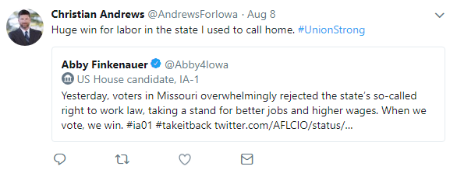

  - According to an Aug. 8, 2018, NPR report, “Voters in Missouri have overwhelmingly rejected a right-to-work law passed by the state’s Republican-controlled Legislature that would have banned compulsory union fees — a resounding victory for organized labor that spent millions of dollars to defeat the measure.

“With about 98 percent of the precincts reporting, the ‘no’ vote on Missouri’s Proposition A, which supported the law, was running about 67 percent, with nearly 33 percent voting ‘yes.’

“In 2017, the right-to-work law passed Missouri’s Republican Legislature and was signed by then-Gov. Eric Greitens. However, union organizers gathered enough signatures to keep it from going into effect pending the results of a statewide referendum. The rejection of Proposition A effectively kills the law.”

EDUCATION

- In 2019, Christian Andrews criticized a meeting between Gov. Kim Reynolds and U.S. Education Secretary Betsy DeVos regarding school vouchers, saying, “please don’t let Gov. Reynolds and the Ed Secretary, ‘crooked’ Betsy Devos, divert our hard earned dollars to private privilege”

  - In a March 15, 2019, Facebook post regarding a Betsy DeVos/Kim Reynolds meeting on vouchers, Christian Andrews said, “Dear Iowa taxpayers ... please don’t let Gov. Reynolds and the Ed Secretary, ‘crooked’ Betsy Devos, divert our hard earned dollars to private privilege.”

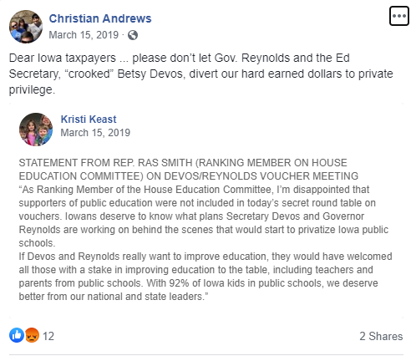

ENVIRONMENT

- Christian Andrews accepts that climate change is happening, adding, “I do believe that immediate attention to human destruction of our environment is past due”

  - In his Iowa Chapter of Sierra Club Questionnaire for State Candidates, when asked if he accepts that climate change is happening, is accelerating, is attributable to human activity, and requires immediate attention by every state legislature including Iowa’s, Christian Andrews replied, “Yes, I do believe that immediate attention to human destruction of our environment is past due.”

- Christian Andrews believes the deposit should be raised to $.50 per deposited bottle

  - In his Iowa Chapter of Sierra Club Questionnaire for State Candidates, when asked if he supports the Bottle Bill “as is,” Christian Andrews replied, “Yes, but only as a last resort. I am not educated enough on this, but I believe we should raise the deposit to $.50 per deposited bottle in drinking receptacle.” When asked if he would support some additions to the bottle bill, such as water bottles, Christian Andrews replied, “Yes, I would consider ALL sold drinking receptacles. I don’t know all of the effects on small businesses, but I really want to explore this more.”

- Christian Andrews said that he believes it is time to end the use coal fuel at the UNI power plant

  - In his Iowa Chapter of Sierra Club Questionnaire for State Candidates, when asked if he would support ending the use of coal by state universities, including appropriating the funds to construct renewable energy facilities as needed to provide power, Christian Andrews replied, “Yes, I believe it is time to end the use coal fuel at UNI power plant. I would want to train current workers in a new renewable energy facility on campus.”

TAXES

- Christian Andrews said he would vote to extend the one-cent SAVE sales tax and would look at removing the sunset clause on the tax

According to an Oct. 21, 2018, candidate profile in The Gazette, when asked his thoughts on increasing funding for public education and whether he would vote to extend 1-cent SAVE sales tax for school infrastructure until 2049, Christian Andrews replied, “We need to make sure our public schools are stable and support all students. In fact, I would vote to extend SAVE and even look at removing the sunset clause.”

- Christian Andrews supports removing the Social Security tax cap

  - In a Dec. 9, 2019, Facebook post, Christian Andrews wrote, “Don’t cut it...fund it. Raise the limit on every dollar earned, don’t stop at $110,000.00. Everyone needs to pay their fair share.”

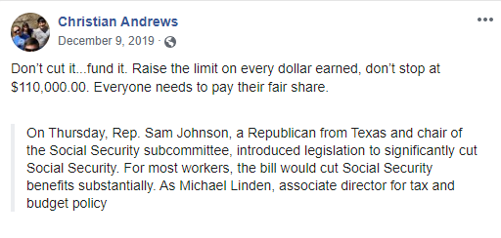

- In 2012, Christian Andrews said that under George W. Bush, there was not a need to lower taxes for anyone, adding, “The $600 I got back on my taxes was a joke”

  - In a July 8, 2012, comment on a Facebook post, Christian Andrews wrote, “Bush did lower taxes, he did not reduce them much for poor and middle class, nor was there a need to lower them for anyone. The $600 I got back on my taxes was a joke. Under Bill C Congress may have lowered tax on investment income, but Bill made sure we had a balanced budget when he was done in office...Bush jr. Gave away lots of money with the help of Democrats in his Congress, but he didn’t bother to balance the equation; he spent and spent and spent! Hence our current debt load... Clinton and Congress in 90’s had the national debt projected to be paid off by 2012!!! Where did all that money go?”

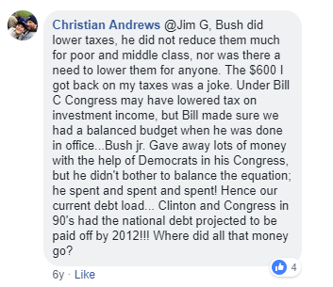

HEALTH CARE

- On abortion, Christian Andrews said that, “The government has no place in that decision or in telling a woman what to do with her body”

  - According to an Oct. 21, 2018, candidate profile in The Gazette, when asked if he would expand or repeal Iowa’s law barring doctors from performing an abortion once a fetal heartbeat is detected, Christian Andrews replied, “The choice of whether or not to have an abortion is between a woman and her doctor. The government has no place in that decision or in telling a woman what to do with her body.”

- In 2012, in reply to a Facebook post asking the favorite Obama accomplishment in his first four years in office, Christian Andrews named Obamacare

  - In an Oct. 24, 2012, comment on a MoveOn.org Facebook post asking the favorite Obama accomplishment during his first four years in office, Christian Andrews wrote, “Affordable Care Act, Wall street Reforms, ending war in Iraq, recognizing All US citizens as such with the same rights regardless of sexual orientation!”

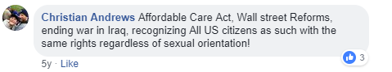

MARIJUANA

- Christian Andrews said that he would support the legalization of marijuana

  - In an Oct. 21, 2018, candidate questionnaire with The Gazette, when asked his position on expanding medical cannabis ad the legalization of marijuana, Christian Andrews said, “I’ve heard from Iowa patients and my own mother-in-law on this issue, and it’s clear that the current law doesn’t help patients enough. We need to increase the number of diseases that can be treated by medical marijuana and increase the THC level per dosage to optimize the potency and effectiveness. I would support the legalization of marijuana.”

SECOND AMENDMENT

- In 2020, Christian Andrews encouraged Gov. Kim Reynolds to veto HF 2502, which prevents cities from regulating the possession of lawfully carried firearms

  - In a June 5, 2020, Facebook post, Christian Andrews wrote, “I’m pro-2nd Amendment. I’m pro-hunting. I’m pro-gun-collecting. I also trust citizens to know what’s best for their own community. Call @KimReynoldsIA (515-281-5211) and tell her to veto HF2502. This bill takes away local control, tax dollars and safety. #IowaStrong”

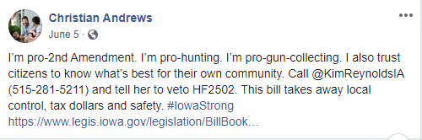

  - In a July 7, 2010, article, The Gazette reported, “Citing the city’s vulnerability to costly lawsuits and legal fees, the Iowa City Council on Tuesday reluctantly lifted a weapons ban on municipal properties.

“‘I’m going to vote for this but it’s with a great, heavy heart,’ said Mayor Bruce Teague. ‘I hate that this is before us tonight.’

“A February 2011 resolution had prohibited weapons in city buildings and on city buses. However, Gov. Kim Reynolds last month signed House File 2502, which prevents cities from regulating the possession of lawfully carried firearms.

“The only exception to the law is if cities provide screening devices and an armed guard at buildings where weapons remained banned.”

- The NRA supported the bill, saying it ensured that Second Amendment rights would remain protected across the state

  - According to a March 11, 2020, article from the NRA, “On March 9th, the Iowa Senate Judiciary Committee passed House File 2502 to protect shooting ranges from being shut down by unreasonable local ordinances and ensure that Second Amendment rights remain protected across the state. It now goes to the full Senate for debate and a floor vote. Please contact your state senator and ask them to SUPPORT HF 2502.”

- In 2013, Christian Andrews said that he thought “people who buy guns in the future need to be vetted better, trained more, and all of us get more mental health care”

  - In a Feb. 4, 2013, comment on a Democrats Facebook post on reducing gun violence, Christian Andrews wrote, “I think people who buy guns in the future need to be vetted better, trained more, and all of us get more mental health care. I truly believe these would slow down and eventually minimize the number of mass shootings.”

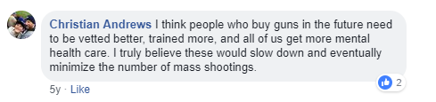

Meet Christian, Christian Andrews for Iowa House website, Accessed July 11, 2020
“Mount Vernon Public Works Employee Christian Andrews Announces Bid for State Representative,” Iowa House Democrats, Feb. 20, 2018
https://www.linkedin.com/in/christian-andrews-28956750/
Business Services: Frequently Asked Questions, Iowa Secretary of State’s Office, Accessed Aug. 29, 2018
Trade Name Laws, Black Hawk County Recorder, Accessed Aug. 29, 2018
Trade Name Laws, Black Hawk County Recorder, Accessed Aug. 29, 2018
Business Entity Search: Good Wood, Iowa Secretary of State, Accessed Aug. 29, 2018
https://www.facebook.com/christian.andrews.gw/posts/2360324807323101
Brianne Pfannenstiel, “Range of possible 2020 messages at Dem dinner,” Des Moines Register, Dec. 23, 2018
Brianne Pfannenstiel, “Range of possible 2020 messages at Dem dinner,” Des Moines Register, Dec. 23, 2018
https://twitter.com/AndrewsForIowa/status/1027319265098182656
Scott Neuman, “Missouri Blocks Right-To-Work Law,” NPR, Aug. 8, 2018
https://www.facebook.com/christian.andrews.gw/posts/2244940025528247
Questionnaire for State Candidates: Christian Andrews, Iowa Chapter of the Sierra Club,
Questionnaire for State Candidates: Christian Andrews, Iowa Chapter of the Sierra Club,
Questionnaire for State Candidates: Christian Andrews, Iowa Chapter of the Sierra Club,
Candidate Profile: Christian Andrews, The Gazette, Oct. 21, 2018
https://www.facebook.com/christian.andrews.gw/posts/2750835144938730
https://www.facebook.com/PragProgPage/photos/a.194724580545864/455346817816971/?type=3&comment_id=455530467798606
Candidate Profile: Christian Andrews, The Gazette, Oct. 21, 2018
https://www.facebook.com/moveon/posts/10151070063415493?comment_id=10151070384355493
Candidate Profile: Christian Andrews, The Gazette, Oct. 21, 2018
https://www.facebook.com/AndrewsForIowa/posts/1415852871957755
Lee Hermiston, “Reluctant Iowa City Council lifts gun ban to comply with new law,” The Gazette, July 7, 2020
“Iowa: Range Protection & Preemption Bill to Senate Floor,” NRA-ILA, March 11, 2020
https://www.facebook.com/electdemocrats/photos/a.131018881544/10151264821786545/?type=3&comment_id=10151264917561545

