JENNIFER PELLANT REPORT

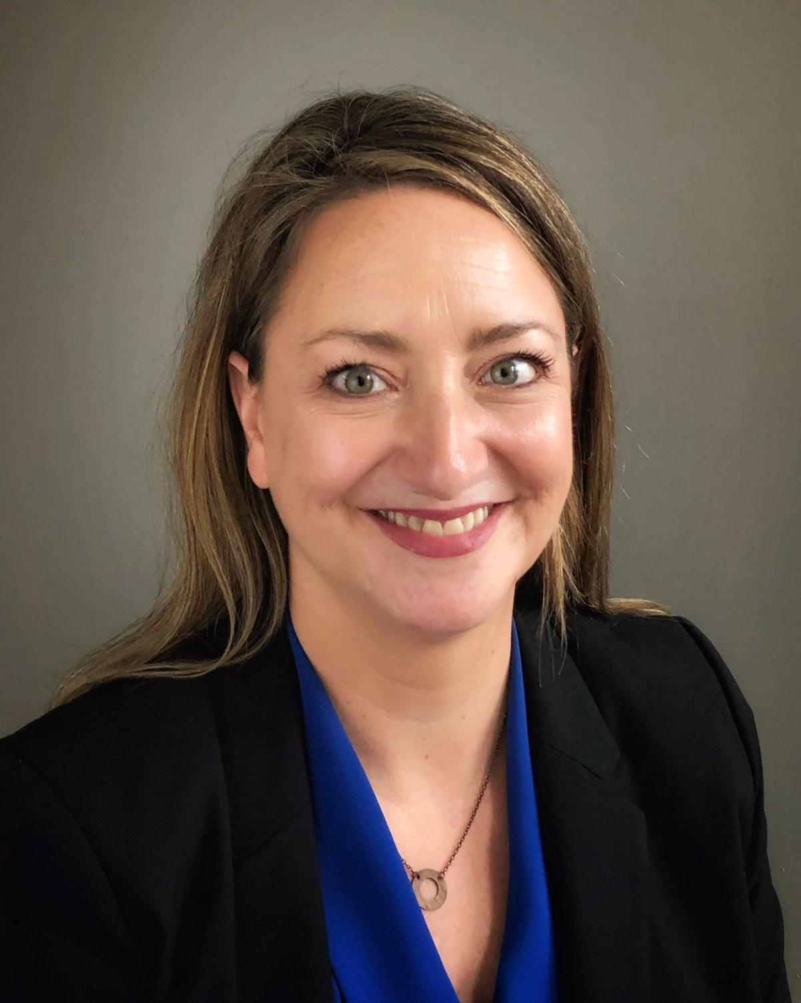

CASCADE STRATEGIES – JULY 2020

TABLE OF CONTENTS

TABLE OF CONTENTS 2
BIOGRAPHY 3
TIMELINE 4
IOWA JOBS 5
CAREER 7
CAMPAIGN FINANCE 10
RIGHT TO WORK 11
TRANSGENDER SCHOOLS 12
ABORTION 15
HEALTH CARE 17
CLIMATE 19
TRUMP 21
MANDATORY MILITARY 22
IMMIGRATION 24

BIOGRAPHY

Name: Jennifer Lyn Pellant

Birth: Aug. 30, 1972

Residence: 3105 Traders Pointe Rd.
Council Bluffs, IA 51501

Parents purchased the house in 2005, and they currently receive the homestead. This address is the same address that Jen Pellant lists as her campaign office, as well as on her financial disclosure statement. As recently as July 2018, Jen Pellant has identified herself as a resident of Chicago.

Family: Single

Education: B.A. English, Journalism, Simpson College
J.D. Law, University of Iowa College of Law

Military: None

Professional Experience: Regional Field Director, Friends of John Delaney
President, Mercury Boost
Director of Human Resources, Industrial Steel Construction
Senior Human Resources Manager, Industrial Steel Construction
Vice President, Bar 1 Events
Director of Marketing, Bar 1 Events
Manager, Bar 1 Events
Speechwriting Intern, Office of Governor Terry Branstad

Political Experience: Regional Field Director, Friends of John Delaney

TIMELINE

Aug. 30, 1972 Born in Des Moines, IA

1990-1994 B.A. English, Journalism, Simpson College

1991-1992 Speechwriting Intern, Office of Governor Terry
Branstad

1994-1997 J.D., University of Iowa College of Law
1998-2000 Manager, Bar 1 Events

2000-2009 Director of Marketing, Bar 1 Events

2009-2013 Vice President, Bar 1 Events

2013-2014 Senior Human Resources Manager, Industrial Steel
Construction

2014-2019 Director of Human Resources, Industrial Steel
Construction

2019-2020 Regional Field Director, Friends of John Delaney

2020-Present President, Mercury Boost

IOWA JOBS

- In 2019, Jen Pellant was “celebrating the marriage of a rural community & a tech company,” calling it an “Amazing blueprint for the kind of community development that can bring good jobs and opportunities to young people in rural Iowa”

  - On Sept. 7, 2019, Jen Pellant tweeted, “At the Pillar Forge in Jefferson, IA learning & celebrating the marriage of a rural community & a tech company. Amazing blueprint for the kind of community development that can bring good jobs and opportunities to young people in rural Iowa. #brilliant #focusonthefuture #IA04”

- In her campaign for the Iowa House, Jen Pellant says that she will fight for a diverse and dynamic 21st century economy in Council Bluffs

  - According to the Jen Pellant for Iowa website, “For most of my career I worked in small businesses in hospitality and manufacturing. I know first-hand that Main Street businesses build communities and create jobs. I will fight for a diverse and dynamic 21st century economy in Council Bluffs — one that provides residents with well-paying, modern jobs and careers by supporting small business ingenuity, entrepreneurism, and workers’ rights.”

- After the John Delaney presidential campaign ended, Jen Pellant and a friend started Mercury Boost, a media marketing solutions company; On her LinkedIn page, Jen Pellant lists herself as president of the company

  - In a March 12, 2020, article, the Daily Nonpareil reported, “After a few years working behind the scenes, Jen Pellant decided to come to the fore.

“Pellant, a Democrat, is running for the Iowa House District 16 seat currently held by the retiring Rep. Mary Ann Hanusa. The district includes eastern and southern areas of Council Bluffs.”

  - According to the same article, “Since the Delaney campaign ended, Pellant and a friend have started Mercury Boost, a media marketing solutions company. The candidate said she’d focus on building an Iowa economy that supports and encourages small business growth.

“‘Those are the biggest job providers in a community, and they add a vibrancy and sense of community that is important,’ she said, gesturing out the window. ‘What’s happened here on the 100 Block is a great example.’”

  - According to her LinkedIn page, Jen Pellant lists herself as President at Mercury Boost.

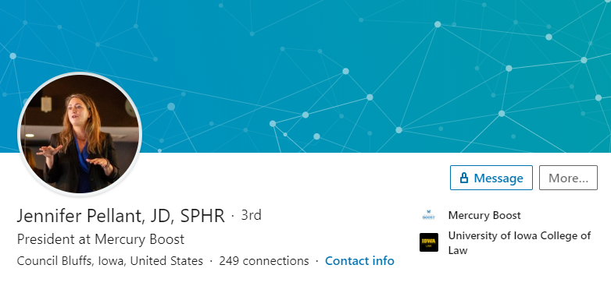

- On its website, Mercury Boost touts itself as having “professionals in rural Iowa working alongside talented designers and web experts in Milwaukee, Wisconsin”

  - According to the Mercury Boost website, “Whether your organization is emerging or mature, whether you are looking for basic online needs, or a robust targeted strategy, Mercury Boost is there to give you the edge with friendly and fast service, on-the-ground knowledge of how to make the Internet work for you and professionals trusted by the Philadelphia Inquirer and Tampa Bay Times to deliver services to clients in those major metros.

“Collecting ‘friends’ and hoping Google searches land on your business or organization is not enough in this competitive digital environment. You need a strategy to maximize your web and social media presence so Facebook and Instagram and Google driving customers and clients and patients to your services. We understand the digital space and can develop a range of packages to take the guesswork and finger-crossing experiments out of your online brand and marketing.

“We understand both rural and metropolitan clients. We have professionals in rural Iowa working alongside talented designers and web experts in Milwaukee, Wisconsin.”

CAREER

- On her LinkedIn page, Jen Pellant lists her titles as JD and SPHR; Her work experience includes Bar1 Events, Industrial Steel Construction, Friends of John Delaney, and president of Mercury Boost

  - According to her LinkedIn page, Jen Pellant lists her titles as JD, SPHR. According to her profile, she worked at Bar1 Events from 1998-2013, Industrial Steel Construction from 2013-2019, Friends of John Delaney from 2019-2020, and as President of Mercury Boost from March 2020 – Present.

- Jen Pellant is not a licensed attorney in Iowa

  - According to the Iowa Judicial Branch, no records exist for any attorney in Iowa named Pellant.

- Jen Pellant is a licensed attorney in Illinois, but according to the Supreme Court of Illinois, she is, “Not authorized to practice law as attorney is not currently registered with ARDC and has not demonstrated required MCLE compliance”

  - According to the Attorney Registration & Disciplinary Commission of the Supreme Court of Illinois, Jennifer L. Pellant was admitted to the Illinois bar on Nov. 6, 1997. According to the Commission, Jennifer Pellant’s status with the bar is, “Not authorized to practice law as attorney is not currently registered with ARDC and has not demonstrated required MCLE compliance.”

- Jen Pellant says that although her legal education proved valuable, a career in law was not ultimately her calling, adding that she chose to join a small hospitality group

  - According to the Jen Pellant for Iowa website, “I graduated from Lewis Central High School and went to college at Simpson College in Indianola, Iowa. After graduating from Simpson, I went to law school at the University of Iowa. Although the legal education proved valuable, a career in law was not ultimately my calling. Instead, I chose to pursue an opportunity in small business, joining a small but growing hospitality group. That opportunity led to roles in management, marketing, event planning, community outreach, fundraising, and eventually, human resources. After several years in the restaurant business, I moved on to a role as the Director of Human Resources for a small steel fabrication company, learning the business of manufacturing and heavy construction as well.”

- In 2009, Jen Pellant was identified in the Chicago Tribune as a bartender for McGees Tavern & Grille in Chicago

  - In an Oct. 31, 2009, article, the Chicago Tribune reported, “In Lincoln Park, McGees Tavern & Grille celebrates pumpkins by hollowing out 200 gourds each year for customers to carve, then puts them on display in front of the bar.

“‘All the managers are up to their elbows in pumpkin guts,’ bartender Jen Pellant told RedEye as the tavern prepped for Halloween.”

  - According to the same article, “In Lincoln Park, McGees Tavern & Grille celebrates pumpkins by hollowing out 200 gourds each year for customers to carve, then puts them on display in front of the bar.

“‘All the managers are up to their elbows in pumpkin guts,’ bartender Jen Pellant told RedEye as the tavern prepped for Halloween.”

- Jen Pellant worked with Bar 1 Events, a marketing/promotion business for a group of bars and restaurants

  - According to the May/June 2012 Sheffield Neighborhood News, “Brothers Phil and Tom Piazza, proprietors of McGee’s Tavern and Grill, 950 W. Webster, are celebrating their 25th year of operation. They opened their doors in March 1988, serving fine libations and excellent food to residents of the Sheffield community and DePaul University students, staff, and faculty.”

  - According to the same article, “Continually growing their businesses, Phil and Tom operate with the help of long-time employee Jen Pellant of Bar 1 Events, a marketing/promotion business for their group of hospitality locations to promote events to the Piazzas’ many customers, including parties and public service contributions. Jen has faithfully for many years donated her time and talent helping to prepare promotion materials and communications for the Sheffield Garden Walk & Festival.”

- Jen Pellant’s YouTube page includes videos of the Screw Cupid Pub Crawl, Harlem Shake Duffy’s Edition, and Roadwatch

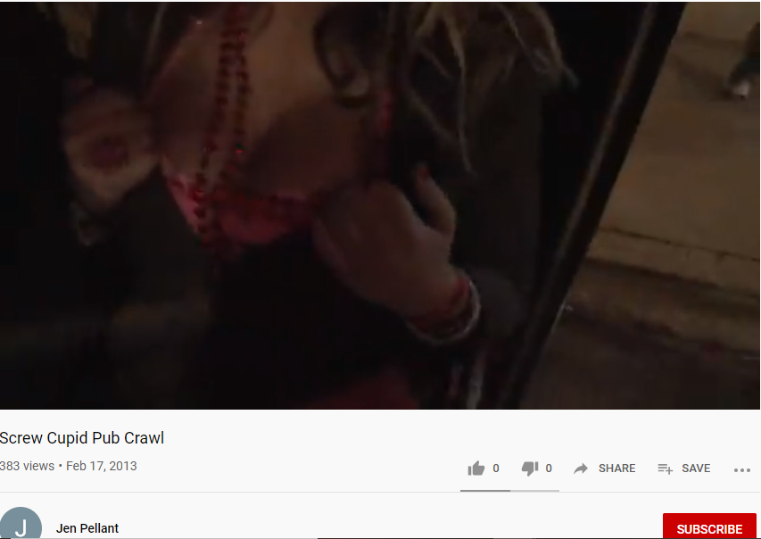

CAMPAIGN FINANCE

- Jen Pellant’s three largest campaign contributions have come from outside of Iowa, as of May 26, 2020

  - According to the Iowa Ethics & Campaign Disclosure Board, Jen Pellant for Iowa has taken the following campaign contributions over $1,000.

Donor | City | Amount
Karla Jurvetson | Los Altos, CA | $2,000
Kevin Rowe | Santa Fe, NM | $1,000
Karla Jurvetson | Los Altos, CA | $5,600

- Jen Pellant has taken at least $7,600 from Silicon Valley psychiatrist Karla Jurvetson, who in February 2020 gave a total of $14.6 million to a super PAC backing Elizabeth Warren’s presidential campaign

  - In a March 20, 2020, article, Vox.com reported, “A little-known Silicon Valley psychiatrist has cemented herself among the most powerful donors in Democratic politics, thanks to a massive gift to support Elizabeth Warren’s failed presidential bid in its final weeks. That money will make her among the most sought after political donors in the country up until November.

“Karla Jurvetson, who has slowly been turning heads in the world of Bay Area fundraising, gave a total of $14.6 million in February to a super PAC backing Warren, according to new disclosures filed late Friday night. Those donations together constitute one of the largest gifts of the entire 2020 presidential campaign, and ranks Jurvetson among brand-name Democratic donors like Mike Bloomberg and Tom Steyer in terms of total contributions to outside groups this cycle — and it makes her the biggest woman donor. In this cycle, Steyer has given about $30 million to liberal groups, and Bloomberg about $15 million, not including their own presidential campaigns.”

RIGHT TO WORK

- In 2019, Jen Pellant called Right to Work legislation a disaster for workers

  - In a Nov. 25, 2019, Facebook post, Jen Pellant wrote, “Although very cleverly named, ‘right to work’ legislation is actually a disaster for workers. Sad to see Iowa in the bottom 10 states for workers. We need to turn that around, raise wages, and improve benefits for Iowans.”

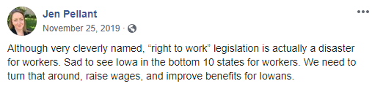

TRANSGENDER SCHOOLS

- In July 2018 (while listing her address as Chicago, IL), Jen Pellant wrote a letter to the Delaware Department of Education, asking the board to withdraw Regulation 225

  - In a July 6, 2018, e-mail to the Delaware Department of Education, Jen Pellant wrote, “As a person who believes in fairness and equality for everyone, I am urging you to withdraw Regulation 225.

“State governments should be making sure that all students, including transgender students, can learn in safe and supportive schools. But this regulation will make it harder for schools to do the right thing and support transgender students—and in some cases it’ll make it impossible. It sends schools the message that discriminating against transgender kids is okay, and it sends transgender kids the message that their government doesn’t think they’re worthy of the same respect as everyone else. Kids in Delaware deserve better than this.

“Jennifer Pellant

“Chicago, IL 60616”
- Regulation 225 was originally intended to protect students who might fear retaliation from their parents if they revealed that they were transgender; In June 2018, Education Secretary Susan Bunting removed that provision, as well as one that would allow student to choose to play on a sports team “consistent with their gender”

  - In an Aug. 2, 2018, article, WHYY reported, “Andrea Rashbaum, the mother of a transgender child and member of a panel Delaware Gov. John Carney’s administration formed last year to develop an anti-bias policy for schools, had predicted ‘they are going to just let it float away in the wind.’

“Rashbaum, a teacher, expressed those concerns during a February interview amid controversy over a provision that would have, in special circumstances, allowed students to use a different name at school than at home without the school notifying their parents.

“The goal of the proposal, known as Regulation 225, was to protect the few students who might fear retaliation from their parents if they revealed that they were transgender, according to attorney Mark Purpura, an LGBTQ advocate who was on the panel.

“In June, though, one of Rashbaum’s fears came true when state Education Secretary Susan Bunting removed that provision, as well as one that would allow student to choose to play on a sports team ‘consistent with their gender.’

“And on Thursday, Rashbaum’s words proved prophetic when Carney and Bunting’s office announced no policy would be adopted — contrary to what Carney had ordered in July 2017.”

- Parents were adamantly opposed to Regulation 225 in its original form, which would have allowed students to self-identify their gender or race in schools, saying it stripped parents of their rights to make decisions for their children. Those complaints led to a revised measure which would’ve required parental permission

  - In an Aug. 2, 2018, article, WDEL reported, “The Delaware Department of Education won’t be moving forward with a controversial regulation which would’ve allowed students to self-identify their gender or race in schools.

“Parents were adamantly opposed to Regulation 225 in its original form, saying it stripped parents of their rights to make decisions for their children. Those complaints led to a revised measure which would've required parental permission.”

GUN CONTROL

- In 2019, Jen Pellant tweeted that we deserve common sense gun laws in this country, adding that John Delaney “will get gun reform done”

  - In a March 22, 2019, tweet, Jen Pellant wrote, “This is ridiculous and unnecessary. We deserve common sense gun laws in this country, not more active shooter drills. We just need smart and courageous leadership. I know a guy. @JohnDelaney will get gun reform done.”

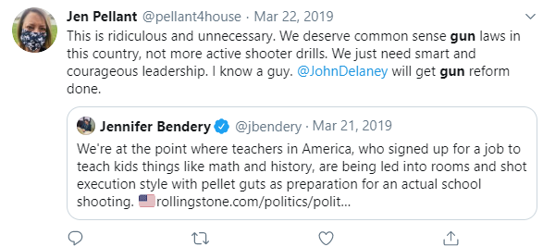

- John Delaney’s gun control plan included supporting universal background checks; a ban on assault weapons, high-capacity magazines, and accessories like bump stocks and trigger cranks, and encouraging states to adopt risk protection order laws that allow family members to petition courts to restrict access to guns for people who pose an immediate threat to themselves or others

  - In a Nov. 7, 2019, article in USA Today, when asked how he would address gun violence in America, John Delaney responded, “I support universal background checks; a ban on assault weapons, high-capacity magazines, and accessories like bump stocks and trigger cranks that increase the rate of fire for semiautomatic weapons; closing the boyfriend loophole to prevent people convicted of domestic violence against a dating partner from buying guns; encouraging states to adopt extreme risk protection order laws that allow family members to petition courts to restrict access to guns for people who pose an immediate threat to themselves or others; and federal funding for gun violence research.”

ABORTION

- On her Facebook page, Jen Pellant posted a profile picture caption which read, “Stop Abortion Bans Now”

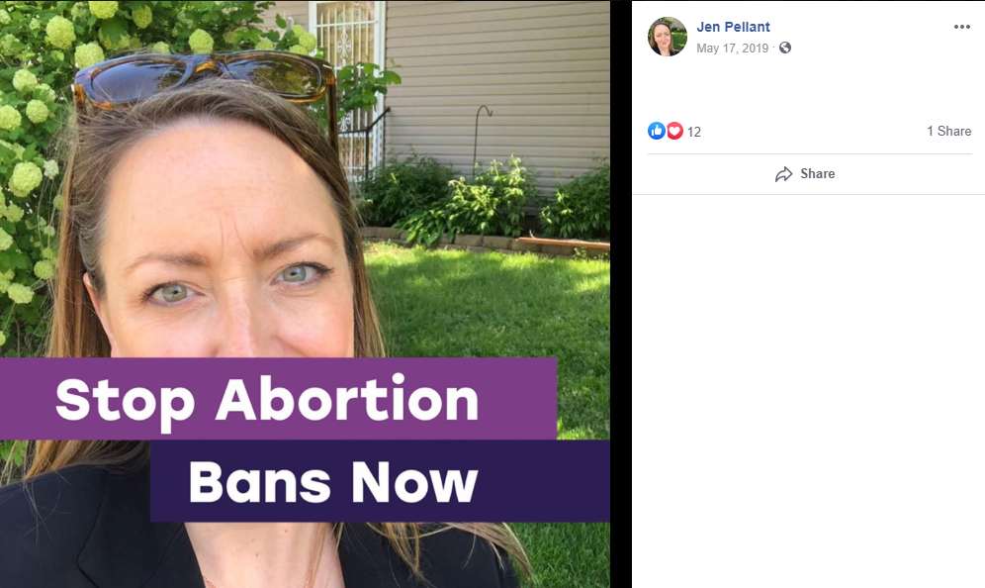

- In 2019, Jen Pellant tweeted that the because of Hyde Amendment, Medicaid won’t cover abortions, so the right to an abortion isn’t “real” for some women

  - In a May 29, 2019, tweet, Jen Pellant wrote, “If you are a woman who is an hourly wage worker in Sedalia, MO, how ‘real’ is your right to an abortion now? Thanks to the Hyde Amendment, Medicaid won’t cover the procedure, so you have to somehow scrape up enough cash to cover it out-of-pocket...”

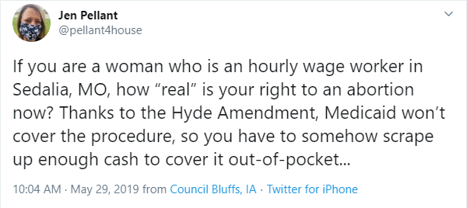

- Jen Pellant tweeted that women all over the country live in healthcare deserts where abortion is already inaccessible, adding, :We need to wake up and work on EXPANDING reproductive healthcare for ALL”

  - In a May 29, 2019, tweet, Jen Pellant wrote, “This is a crisis point for Missouri, for sure. But there are women all over the country having their own ‘crisis points’ every day. They live in healthcare deserts where abortion is already inaccessible. We need to wake up and work on EXPANDING reproductive healthcare for ALL.”

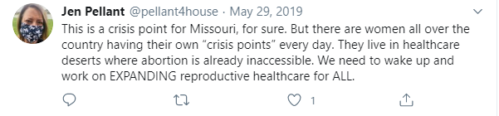

HEALTH CARE

- In 2019, Jen Pellant touted John Delaney’s health care plan

  - In an Aug. 19, 2019, Facebook post, Jen Pellant wrote, “My favorite part of this article is where an economist claims that John Delaney is ‘wrong -- full stop’ on his assessment of the effect of M4A on rural hospitals and then goes on to say that ‘it’s more likely hospitals will be forced to scale back services, amenities and staff under a Medicare for All system.’

“Ummm...is that really better???

“How about we just add universal healthcare for every man, woman, and child in this country, as proposed by John Delaney, without wiping out the private insurance market in the bargain? Without knowing how disruptive M4A will be, that seems like the smarter way to proceed.”

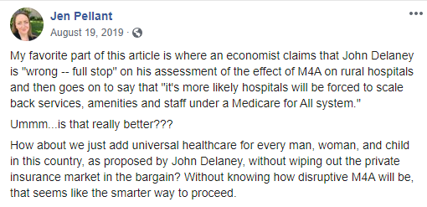

- John Delaney would create a new public health care plan for all Americans under the age of 65; Individuals would be automatically enrolled in the public plan, and would be allowed to opt-out and receive a tax credit to buy their own insurance policy if they choose

  - According to the John Delaney for President website, “Create a new public health care plan for all Americans under the age of 65 while preserving traditional Medicare. The new plan would protect the reforms delivered by the Affordable Care Act, including guaranteed coverage of preexisting conditions and essential health benefits, and would make access truly universal. At 65, people would transition into Medicare. Medicaid would be absorbed by the new plan. The highly trusted Medicare provider network could be used for the new plan.

“Guarantee universal coverage. Individuals would be automatically enrolled in the new public plan, with no complicated procedures to follow. People would be allowed to opt-out and receive a tax credit to buy their own insurance policy if they choose.

“Keep private insurance options. Individuals and employers will be able to purchase and negotiate supplemental coverage from private insurers to cover additional health needs. These supplementals could merge into the basic plan to make it easier for the user.

“Employers would be encouraged to negotiate group rate supplemental plans that would merge with the basic governmental plan so that employees would be able to keep similar health care plans, many of which are very popular and important to American families.”

- In 2020, Jen Pellant said, “I’m fighting for candidates at all levels of government who are going to fight for universal healthcare for all”

  - In a Jan. 9, 2020, Facebook post, Jen Pellant wrote, “It’s frustrating and disappointing that we live in a society where we have to crowdfund to help our neighbors with their health crises. That’s why I’m fighting for candidates at all levels of government who are going to fight for universal healthcare for all.

“In the meantime, if you can help out Kendra and her mom, Nancy, I would really appreciate it. I met them on the caucus trail, and they are wonderful, generous, hardworking people who both work in caregiving jobs themselves. But they’ve had a rough year in terms of health, and as many of us can relate, that can be draining both emotionally and financially. Thanks for any a$$istance you can provide!”

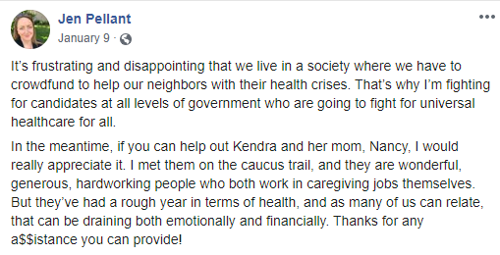

CLIMATE

- In 2019, Jen Pellant touted John Delaney’s solutions to climate change

  - In a March 20, 2019, Facebook post, Jen Pellant wrote, “I want my next President to be as smart as this guy. We’ve got big problems to solve and we need more smart (and achievable) solutions like these. If you want to hear more about this (and other great ideas by John Delaney) on the Democratic debate stage, become one of our 65,000 donors today at johndelaney.com!”

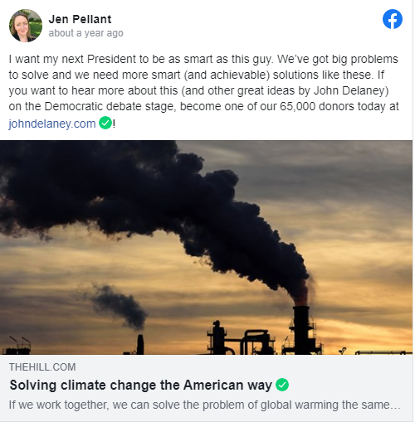

- John Delaney’s plan included a carbon tax-dividend law

  - In a March 20, 2019, op-ed in The Hill, John Delaney wrote, “Global warming is an existential crisis. The overwhelming consensus in the scientific community is that global warming will threaten the prosperity and security of not only every American, but people around the world.

“To address this threat with the seriousness and analytical clarity that it deserves we have to focus on one core goal: reducing the amount of greenhouse gases in the atmosphere. This comes with acknowledging four core realties: First, we should not make action on climate harder to solve by linking it to other issues of inequality or injustice. This will only delay real action on climate and time is our enemy. When John F. Kennedy said we should send someone to the moon, he didn’t tie it to unrelated social or economic policies. He marshalled significant resources and talent and had a laser-like focus on the goal. Second, we need to propose solutions that don’t radically disrupt the entire economy, or shift all of the burdens to the poor or working class. Focusing on ideas that many in the country oppose will only delay real action on climate. Third, we have to acknowledge that solving the climate crisis involves transitioning off fossil fuels over time, not immediately eliminating fossil fuels. While many don’t like to admit it, fossil fuels produce 80 percent of the world’s energy. Currently, there are not enough alternative energy sources to transition off fossil fuels in the short term.”

  - According to the same article, “Based on these realties, the United States should pursue the following national strategy. First, pass a carbon tax-dividend law, similar to the bipartisan bill I lead in the Congress. The American people will accept this approach and this alone will reduce emissions 90 percent by 2050. A coalition of Democrats and coastal Republicans can pass this law. Second, significantly increase investment in basic energy research around storage, transmission, carbon capture and advanced nuclear. We fundamentally need new technologies to solve this problem and the United States must – and can - lead in ‘cracking the code’ on these technologies.”

- John Delaney said he would rejoin the Paris Climate Agreement on Day 1 of his presidency

  - According to the John Delaney for President website, “According to the IPCC, limiting global warming to 1.5°C will require achieving net zero emissions by 2050. We are already seeing the early effects of climate change, and that level of rapid emissions reductions is necessary to avoid the catastrophic consequences that would result from any further delay. The difference between the warming we have already experienced and the 2°C warming we could see if we don’t act now to reduce emissions is a greater risk of water scarcity, increased sea-level rise, greater damage to ecosystems and animal habitats, declines in human health, and the displacement of millions of people. In addition to the environmental effects, the Department of Defense has characterized climate change as a threat multiplier. Delaney’s plan will put us on the right track to reduce emissions in time to avoid the worst consequences of global warming. However, we need the international community to come together to combat global warming which is why Delaney would also rejoin the Paris Climate Agreement on Day 1 of his presidency.”

TRUMP

- In 2019, Jen Pellant criticized Donald Trump for tweeting racist attacks, adding, “his messages of hate tend to land most effectively in communities that are homogenous, where people are likely never exposed to the kinds of people they so virulently come to despise and demonize”

  - In a July 28, 2019, Facebook post, Jen Pellant wrote, “So, the boss did a thing today...and I urge you to read WHY. John Delaney was the first candidate of this cycle to propose national service, and now he argues it should be mandatory. Can I be honest? I bristled at the word at first. We’re Americans, and we don’t like being told we HAVE to do anything. But, here’s the thing. On further reflection, I think he’s right.

“We’ve had national service options -- military, Peace Corps, AmeriCorps -- for years, and the truth is that relatively few Americans participate. Rural Iowans serve, especially in the military, at higher than national rates, but even at that, it is a minority of our young people.

“Meanwhile, our deep societal divisions grow. We are less and less able to talk to each other, work together, or even understand or empathize with those folks not like ourselves. Our President tweets racist attacks with ever-increasing frequency, and his messages of hate tend to land most effectively in communities that are homogenous, where people are likely never exposed to the kinds of people they so virulently come to despise and demonize.”

MANDATORY MILITARY

- In 2019, Jen Pellant said that she supported mandatory national service, saying, “We live in a country where virtually no sacrifice is asked of most of us anymore, let alone required”

  - In a July 28, 2019, Facebook post, Jen Pellant wrote, “So, the boss did a thing today...and I urge you to read WHY. John Delaney was the first candidate of this cycle to propose national service, and now he argues it should be mandatory. Can I be honest? I bristled at the word at first. We’re Americans, and we don’t like being told we HAVE to do anything. But, here’s the thing. On further reflection, I think he’s right.

“We’ve had national service options -- military, Peace Corps, AmeriCorps -- for years, and the truth is that relatively few Americans participate. Rural Iowans serve, especially in the military, at higher than national rates, but even at that, it is a minority of our young people.

“Meanwhile, our deep societal divisions grow. We are less and less able to talk to each other, work together, or even understand or empathize with those folks not like ourselves. Our President tweets racist attacks with ever-increasing frequency, and his messages of hate tend to land most effectively in communities that are homogenous, where people are likely never exposed to the kinds of people they so virulently come to despise and demonize.

“So, what are we to do? National service is a great idea, but decades of optional service have shown that those folks who need it the most are least likely to choose it. Kids who are isolated by geography or insulated by wealth. Kids who may not even be aware that such a thing exists or know how to get involved.

“So, I agree with Congressman Delaney. It’s time to make this part of the bargain. We live in a country where virtually no sacrifice is asked of most of us anymore, let alone required. Where, after 9/11, President Bush’s big ask was that we get out and shop. Of course, some give all (and their service should never be diminished), but many (including our current President) give nothing.

“If he has accomplished nothing else, our current President has shown us how deeply divided we are and how quickly those divisions can be mobilized and weaponized to tear apart our communities, our democracy, and our institutions. Now is not the time for half-measures and easily-dismissed requests. We need to force ourselves out of our comfort zones and into cooperation with each other. We need this bold plan to stitch the very fabric of our nation back together.”

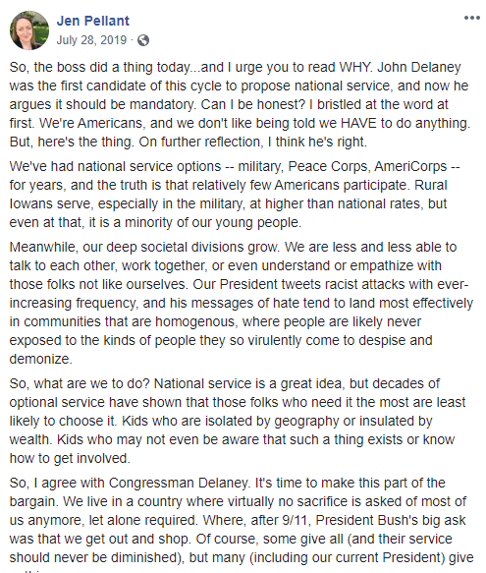

IMMIGRATION

- In 2020, Jen Pellant said that, “We need a permanent path to citizenship for #Dreamers”

  - On June 18, 2020, Jen Pellant tweeted, “This is good news, and yet, no #DACA recipient should have to rely on a razor thin majority to keep them in the only country they’ve ever known as home.

“We need a permanent path to citizenship for #Dreamers.”

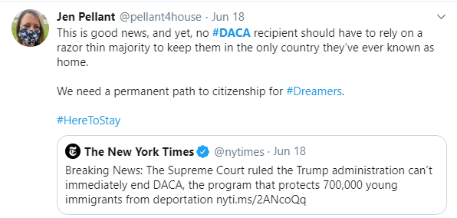

https://twitter.com/pellant4house/status/1170481410303561731
Economy, Jen Pellant for Iowa website, Accessed July 11, 2020
Mike Brownlee, “Pellant talks focus on education, ‘everyday Iowans’ in race for Iowa House District 16 seat,” Daily Nonpareil, March 12, 2020
Mike Brownlee, “Pellant talks focus on education, ‘everyday Iowans’ in race for Iowa House District 16 seat,” Daily Nonpareil, March 12, 2020
https://www.linkedin.com/in/jenniferpellant/
About Mercury Boost, Mercury Boost website, Accessed July 10, 2020
https://www.linkedin.com/in/jenniferpellant/
Lawyers Licensed in Iowa: Pellant, Iowa Judicial Branch, Accessed July 10, 2020
Lawyer Search: Pellant, Attorney Registration & Disciplinary Commission of the Supreme Court of Illinois, Accessed July 10, 2020
Meet Jen, Jen Pellant for Iowa website, Accessed July 10, 2020
Chelsea Schneider, “Orange crush,” Chicago Tribune, Oct. 31, 2009
Chelsea Schneider, “Orange crush,” Chicago Tribune, Oct. 31, 2009
Tom Lawson, “McGee’s Tavern and Grill marks 25th anniversary in Sheffield,” Sheffield Neighborhood News, May/June 2012
Tom Lawson, “McGee’s Tavern and Grill marks 25th anniversary in Sheffield,” Sheffield Neighborhood News, May/June 2012
https://www.youtube.com/channel/UClLEHBOn89skfridtv1CXhg
Contributions to Committee: Pellant, Iowa Ethics & Campaign Disclosure Board, Accessed July 10, 2020
Theodore Schleifer, “A little-known Silicon Valley psychiatrist has become one of the Democratic Party’s most powerful donors,” Vox.com, March 20, 2020
https://www.facebook.com/jen.pellant.9/posts/177629786691300
Jennifer Pellant DOE Regulations Comment email to Delaware Department of Education, July 6, 2018
Chris Barrish, “Carney team scraps proposed anti-bias policy for Delaware transgender students,” WHYY, Aug. 2, 2018
Amy Cherry, “Regulation which would’ve let students self-identify race, gender won’t move forward,” WDEL, Aug. 2, 2018
https://twitter.com/pellant4house/status/1109095037567205376
“John Delaney: 2020 Democratic presidential candidate shares his views on current issues,” USA Today, Nov. 7, 2019
https://www.facebook.com/photo.php?fbid=140732170381062&set=ecnf.100033328384625
https://twitter.com/pellant4house/status/1133735837143883776
https://twitter.com/pellant4house/status/1133738753443422209
https://www.facebook.com/jen.pellant.9/posts/159098838544395
BetterCare: John Delaney’s Plan For Universal Health Care, John Delaney for President, Accessed July 3, 2020
https://www.facebook.com/jen.pellant.9/posts/186216772499268
https://www.facebook.com/jen.pellant.9/posts/127329078388038
John Delaney op-ed, “Solving climate change the American way,” The Hill, March 20, 2019
John Delaney op-ed, “Solving climate change the American way,” The Hill, March 20, 2019
Climate Change, John Delaney for President website, Accessed July 9, 2020
https://www.facebook.com/jen.pellant.9/posts/155097932277819
https://www.facebook.com/jen.pellant.9/posts/155097932277819
https://twitter.com/pellant4house/status/1273647615251546122

