MARIE GLEASON REPORT

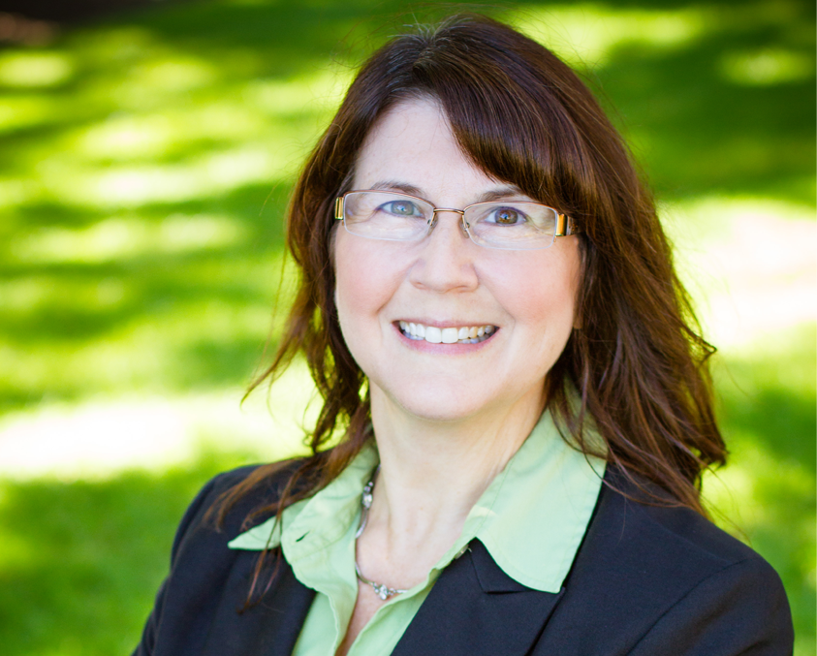

CASCADE STRATEGIES – JULY 2020

TABLE OF CONTENTS

TABLE OF CONTENTS 2
BIOGRAPHY 3
TIMELINE 4
TAXES 5
SECOND AMENDMENT 7
ABORTION 8
POLITICAL PHILOSOPHY 10
IMMIGRATION 12
VOTER ID 15

BIOGRAPHY

Name: Marie Ann Gleason
Birth: Aug. 24, 1964

Residence: 3055 Belmont Pl
Riverdale, IA 52722

Family: Single

Education: B.S. in Business Management, Indiana University at Bloomington
M.A. in Organizational Management, Tusculum University
Certificate in European Studies, Tilburg University

Military: None

Professional Experience: Project Manager for Diversity and Inclusion, John Deere
Former Parliamentary Assistant, European Parliament
Former Intern, United States House of Representatives

Political Experience: Candidate, Iowa State House of Representatives, District 47, 2018 (lost to Roby Smith 53-47%)

TIMELINE

1964 Born

1982 Graduated from Lowell High School in Indiana

1982-1986 B.S. in Business Management, Indiana University at Bloomington

c. 1986 Worked as an intern for former GOP Rep. Elwood Hillis

1986 Had internship with European Parliament

1997-1999 M.A. in Organizational Management, Tusculum University

1997- present Began working as project manager for diversity and Inclusion, John Deere

2001 Purchased home in North Carolina

2003 Sold home in North Carolina

2018 Lost race for Iowa State Senate, District 47

c. 2019 Retired from John Deere

2020 Candidate for Iowa House of Representatives

TAXES

- In 2018, Marie Gleason faulted Iowa’s state tax cut as being tilted too much to the wealthy

  - In an Oct. 26, 2018, editorial, the Quad-City Times wrote, “In District 47, Sen. Roby Smith, R-Davenport, is seeking a second term. Smith says his goals in the upcoming session will be to work on Davenport’s education funding inequity and seek solutions to juvenile crime issues.”

  - According to the same editorial, “Smith is running against Marie Gleason, a Democrat from Bettendorf who is a human resources project manager at Deere & Co.

“Gleason said that her focus would be to properly fund education and support women’s health care. She also faults this year’s state tax cut as being tilted too much to the wealthy, and she adds Smith has not listened to all of his constituents or reflects their values.”

- The bill was the largest tax cut in Iowa history, and Iowans would have their state tax bills reduced by an average of $300 annually under the bill

  - In a May 30, 2018, article, the Des Moines Register reported, “Iowans will have their state tax bills reduced by an average of $300 annually under a tax cut bill signed by Gov. Kim Reynolds on Wednesday that could become a major campaign issue this fall.

“Reynolds, a Republican who made changes in tax policy a cornerstone of her agenda for the 2018 legislative session, celebrated with about 75 people, including key GOP lawmakers, during a ceremony at MobileDemand, an eastern Iowa manufacturer of rugged tablet computers.”

- In 2018, when asked what Iowa should do with its $127 million surplus, Marie Gleason criticized the tax cuts passed by the legislature, and instead of returning the surplus to taxpayers, Gleason said the funding should go to education, health care and job training

  - In an Oct. 18, 2018, interview with WQAD, when asked what should be done with the state’s $127 million surplus, Marie Gleason responded, “Yeah and I think that gets into the bigger equation in regards to how do we prioritize things in this state? And, um, as you mentioned, that surplus, kind of a one-time hit from the federal tax breaks. Um, I’ve seen Iowa over the last couple of years, decrease, or give tax breaks, but they were tax breaks that went to a lot of out of state companies, as well as to very wealthy people. My position is that, you know, working families should be getting more of those tax breaks.”

  - When WQAD followed up specifically on what should be done with the $127 million, Marie Gleason said, “I think our top priority should be education, public education, health care, and job training.”

- When asked where funding would come from for increased spending on education, particularly from tax increases or spending cuts, Marie Gleason said that it would need to be looked at in a holistic way, and she would collaborate with her colleagues

  - In an Oct. 18, 2018, interview with WQAD, when asked where the money would come from to pay for increased education, particularly from spending cuts or tax increases, Marie Gleason said, “Right, right. The money does need to come from somewhere. I think that’s something that needs to be looked at in a very holistic way. Um, and I would like to have a chance to collaborate with who my colleagues will be, once we get to the other side of this election.”

SECOND AMENDMENT

- Regarding the Second Amendment, Marie Gleason said she supports requiring permits to purchase guns, raising the minimum age to purchase a gun to 21, and temporarily banning alcohol abusers from firearms

  - In a May 18, 2018, Facebook post, Marie Gleason wrote, “My heart aches for those in Texas today. I want to take action so that this does not continue to happen.

“I am re-sharing my post from mid-February...

“There are effective actions that we can take that data conclusively shows will make a difference:

“1) Require permits to purchase
“2) Ban individuals convicted of any violent crime from gun purchase
“3) Make domestic violence offenders surrender firearms
“4) Temporarily ban active alcohol abusers from firearms
“And I’ll add a fifth:
“5) Lift the ban on doing research on gun violence
“Today I'm adding a sixth:
“6) Raise the minimum age for gun possession to 21”

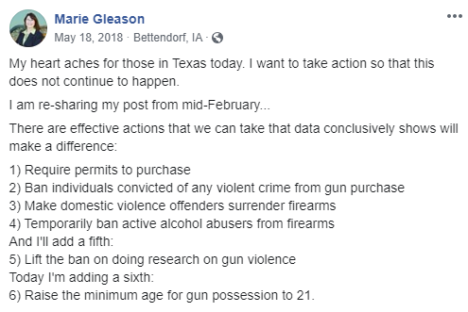
- Marie Gleason said she has not had anyone tell her that we should start arming teachers for school safety

  - In an Oct. 18, 2018, interview with WQAD, when asked about school safety and having administrators or teachers armed in schools, particularly in rural districts, Marie Gleason said, “As I’ve been talking to citizens around the district, I so far have not had even one come up to me and say ‘you know we need to start arming our teachers’”

ABORTION

- In 2018, Marie Gleason called the Iowa abortion ban “appalling”

  - In a June 1, 2018, Facebook post, Marie Gleason wrote, “The appalling six week abortion ban will be stayed pending what will surely be a lengthy and expensive court battle. It is clear now more than ever that a change is needed in our state legislature.”

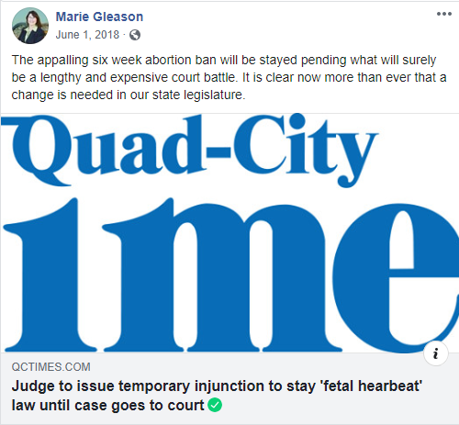

- In 2018, when asked her position on the fetal heartbeat bill, Marie Gleason said that Des Moines politicians do not need to be making healthcare decisions for women

  - In an Oct. 18, 2018, interview with WQAD, when asked about her position on the fetal heartbeat bill, Marie Gleason said, “I guess first off, let me say, you know, Des Moines politicians do not need to be making healthcare decisions for women. I find this very disrespectful to women and I’m hearing that around the district, day in and day out. So I do support increasing access to healthcare and affordable healthcare.”

- In 2018, Marie Gleason touted her endorsement from Planned Parenthood

  - In an Aug. 20, 2018, Facebook post, Marie Gleason wrote, “Thank you Planned Parenthood Voters of Iowa! Together we’ll fight for quality and accessible women’s healthcare across Iowa.”

POLITICAL PHILOSOPHY

- In Marie Gleason’s 2018 campaign for state senate, the Quad-City Times endorsed her opponent, Roby Smith, saying his “answers to our questions were better thought out and more specific”

  - In an Oct. 26, 2018, editorial, the Quad-City Times wrote, “In District 47, Sen. Roby Smith, R-Davenport, is seeking a second term. Smith says his goals in the upcoming session will be to work on Davenport’s education funding inequity and seek solutions to juvenile crime issues.”

  - According to the same editorial, “Smith is running against Marie Gleason, a Democrat from Bettendorf who is a human resources project manager at Deere & Co.

“Gleason said that her focus would be to properly fund education and support women’s health care. She also faults this year’s state tax cut as being tilted too much to the wealthy, and she adds Smith has not listened to all of his constituents or reflects their values.

“We appreciate Gleason’s willingness to step forward and run for office, which she told us stemmed from her alarm over the 2016 election results. However, Smith’s answers to our questions were better thought out and more specific.

“We believe Smith deserves another term.”

- In 2018, Marie Gleason campaigned with U.S. Sen. Jeff Merkley

  - On July 22, 2018, Marie Gleason tweeted, “Great day yesterday door knocking with U.S. Senator Jeff Merkley, Iowa Representative Phyllis Thede, and HD candidate Joan Marttila!”

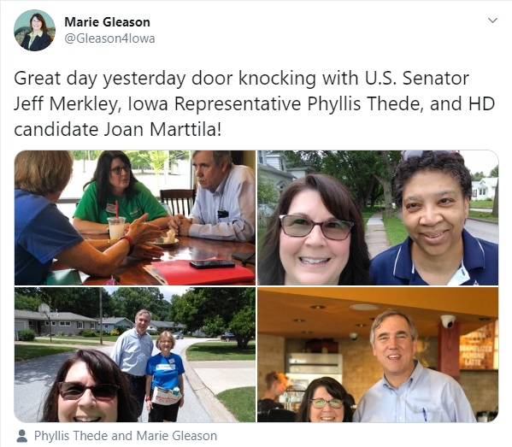

- In 2017, Jeff Merkley joined Bernie Sanders in announcing his “Medicare for All” bill

  - In a Sept. 14, 2017, article, NPR reported, “Sen. Jeff Merkley of Oregon joined Bernie Sanders in announcing his ‘Medicare for All’ bill. Mary Louise Kelly talks to Merkley about why he backs it even though he says it’s not likely to become law.”

- In 2019, Jeff Merkley introduced the Green New Deal with Rep. Alexandria Ocasio-Cortez

  - In an Aug. 22, 2019, article, the New York Daily News reported, “Bernie Sanders rolled out an ambitious $16 trillion plan to combat climate change Thursday, apparently trying to position himself as the most aggressive 2020 candidate on the hot button issue.

“The Vermont senator’s plan is the most expensive climate blueprint floated by a Democratic presidential hopeful and builds on the non-binding ‘Green New Deal’ resolution introduced by New York Rep. Alexandria Ocasio-Cortez and Oregon Sen. Jeff Merkley earlier this year. Sanders’ measure curiously even has the same name.”

- In 2018, Marie Gleason was supported by Rep. Dave Loebsack

  - On June 18, 2018, Dave Loebsack for Iowa tweeted, “Excited to support @Gleason4Senate in Davenport tonight. Marie grew up in a working class family and will fight for Iowans in the middle class and those that want to be part of the middle class. Thanks for having us!”

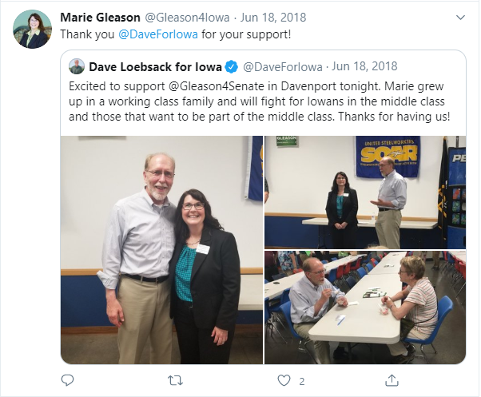

IMMIGRATION

- In June 2018, Marie Gleason praised LULCA Iowa, saying it was “an organization that is doing so many great things across our state”

  - According to a June 16, 2018, Facebook post, Marie Gleason attended the LULAC Iowa 2018 State Convention. Regarding the event, Marie Gleason wrote, “A wonderful evening with an organization that is doing so many great things across our state.”

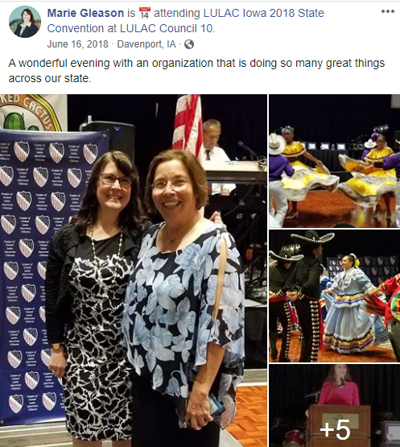

- Two months before Marie Gleason’s Facebook post, members of the League of United Latin American Citizens of Iowa planned to take legal action against the state after Gov. Kim Reynolds signed an immigration enforcement bill into law that banned “sanctuary cities”

  - In an April 10, 2018, article, WQAD reported, “Members of the League of United Latin American Citizens of Iowa plan to take legal action against the state.

“This comes after Iowa Gov. Kim Reynolds signed an immigration enforcement bill into law that bans ‘sanctuary cities,’ Tuesday, April 10.

“The legislation will require law enforcement to follow request from federal agents to hold a jailed person suspected of being in the country illegally.”

- In 2018, LULAC criticized Iowa legislation that would prohibit local governments, cities or counties, from adopting or enforcing policies that discourage enforcement of immigration laws, saying, “The statute is unconstitutional and the most anti-immigrant legislation proposed to date in Iowa”

  - In an April 5, 2018, article, Hola America News reported, “The League of United Latin American Citizens Council 307 in Des Moines has announced its opposition to Senate File 481, known as the ‘Sanctuary Cities Bill.’

“The bill, if approved, would prohibit local governments, cities or counties, from adopting or enforcing policies that discourage enforcement of immigration laws. It also would penalize those cities or counties that do by making them ineligible to receive any state funds.

“‘The statute is unconstitutional and the most anti-immigrant legislation proposed to date in Iowa,’ said Joe Henry, LULAC National vice president of the Midwest and President of Council 307.”

- In 2013, the Iowa LULAC State Director said he was really concerned that Barack Obama’s immigration reform plan did not provide some sort of amnesty to all illegal immigrants

  - According to a Feb. 12, 2013, press release from The Iowa League of United Latin American Citizens, “The Iowa League of United Latin American will meet with two of Iowa’s U.S. Congressmen to discuss issues from the proposed immigration reform plan to the issuance of driver’s licenses for all illegal immigrants, as part of the advocacy group’s trip to the national LULAC Legislative Conference on Feb. 13 and 14 in Washington, D.C.

“Iowa LULAC State Director Joe Enriquez Henry and Deputy Director Mike Reyes will meet with U.S. Reps. Bruce Braley and Dave Loebsack, both Democrats. The men hope to also meet with Republican Congressmen Tom Latham and Steve King, along with U.S. Secretary of Agriculture Tom Vilsack, a Democrat who formerly served as Iowa’s governor.”

  - According to the same release, “Enriquez Henry and Reyes plan to discuss issues that include availability of well-paying jobs, affordable health care access, equality in education and the elimination of poverty. Another important issue to Iowa LULAC is President Barack Obama’s immigration reform package, specifically the requirement that would push so-called illegal immigrants to the back of the line in their journey toward citizenship.

“‘I am really concerned the immigration reform plan does not provide some sort of amnesty to all illegal immigrants,’ Enriquez Henry said. ‘We can’t allow up to 11 million people to wait for years for citizenship. Some cases could take up to 20 years for the person to become a citizen.’”

VOTER ID

- In 2018, Marie Gleason called a judge’s temporary injunction in a lawsuit over Iowa’s voter ID law, “great news”

  - In a July 25, 2018, Facebook post, Marie Gleason wrote, “Great news!

“‘An Iowa judge has granted a temporary injunction in a lawsuit over Iowa’s voter ID law in a development that restores the state's early voting period to 40 days, from 29, and blocks the state from implementing certain identification requirements for early voting.’”

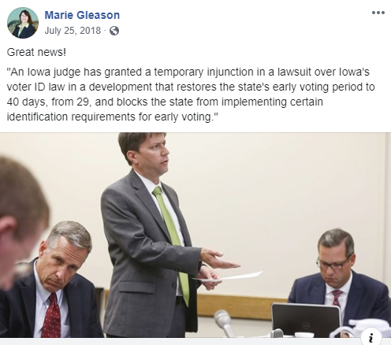

Editorial, “Cournoyer, Smith best choices for state Senate,” Quad-City Times, Oct. 26, 2018
Editorial, “Cournoyer, Smith best choices for state Senate,” Quad-City Times, Oct. 26, 2018
William Petroski, “Reynolds signs largest state tax cut in Iowa history. Here’s how much taxpayers could save,” Des Moines Register, May 30, 2018
Your Voice, Your Vote, Iowa 47th Senate: Marie Gleason, WQAD, Oct. 18, 2018
Your Voice, Your Vote, Iowa 47th Senate: Marie Gleason, WQAD, Oct. 18, 2018
Your Voice, Your Vote, Iowa 47th Senate: Marie Gleason, WQAD, Oct. 18, 2018
https://www.facebook.com/GleasonForIowa/posts/2026928164225294
Your Voice, Your Vote, Iowa 47th Senate: Marie Gleason, WQAD, Oct. 18, 2018
https://www.facebook.com/GleasonForIowa/posts/2032989970285780
Your Voice, Your Vote, Iowa 47th Senate: Marie Gleason, WQAD, Oct. 18, 2018
https://www.facebook.com/GleasonForIowa/posts/2104400196478090
Editorial, “Cournoyer, Smith best choices for state Senate,” Quad-City Times, Oct. 26, 2018
Editorial, “Cournoyer, Smith best choices for state Senate,” Quad-City Times, Oct. 26, 2018
https://twitter.com/Gleason4Iowa/status/1021181586296004608
“Sen. Merkley Makes The Case For ‘Medicare For All’ Bill,” NPR, Sept. 14, 2017
Chris Sommerfeldt, “Bernie Sanders rolls out $16 trillion ‘Green New Deal’ plan,” New York Daily News, Aug. 22, 2019
https://twitter.com/DaveForIowa/status/1008898179394428934
https://www.facebook.com/GleasonForIowa/posts/2041384339446343
“League of United Latin American Citizens plan legal action against Iowa after new ‘Sanctuary Cities’ ban,” WQAD, April 10, 2018
“LULAC opposes bill targeting immigrants, sanctuary cities,” Hola America News, April 5, 2018
Press Release, “LULAC leaders to meet with Iowa Congressmen, attend national conference,” League of United Latin American Citizens, Feb. 12, 2013
Press Release, “LULAC leaders to meet with Iowa Congressmen, attend national conference,” League of United Latin American Citizens, Feb. 12, 2013
https://www.facebook.com/GleasonForIowa/posts/2077804462470997

