NICK MILLER REPORT

CASCADE STRATEGIES – AUGUST 2020

TABLE OF CONTENTS

BIOGRAPHY 3
TIMELINE 4
BERNIE SANDERS 5
AOC 7
ABORTION 8
IMMIGRATION 9
TAXES 10
BUSINESSS 11
PARENTAL RIGHTS 13

BIOGRAPHY

Name: Nicholas Wayne Miller

Birth: Aug. 20, 1998

Residence: 201 N. Parker Blvd.
Polk City, IA 50226

Family: Single

Education: Senior at Drake University

Religion: Methodist

Military: None

Professional Experience: Owner, KNM Productions
Legislative Clerk with Iowa State Rep. Bearinger

Political Experience: None

TIMELINE

Aug. 20, 1998 Born

2011 Founded AVL Specialists (Does not appear to have been registered with Iowa Secretary of State or Polk County)

2017 Graduated from North Polk High School

2018 Began work as clerk for Iowa State Rep. Bruce Bearinger

2018 Started KNM Productions

2019 Announced candidacy for Iowa House of Representatives

BERNIE SANDERS

- In 2016, Nick Miller tweeted that he was ready to caucus, with the hashtag, “#FeelTheBern”

  - On Feb. 1, 2016, Nick Miller tweeted, “Registered and ready to caucus!!! #FeelTheBern #Election2016”

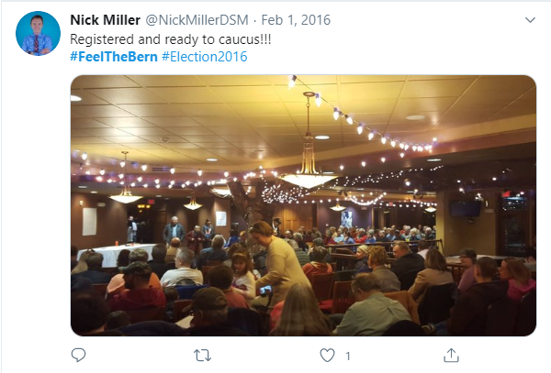

- In 2016, Nick Miller compared the election to Jenga saying, “if you don’t elect the right one, the whole thing crumbles and fails, and the wars begin. #FeelTheBern”

  - On Jan. 30, 2016, Nick Miller tweeted, “#ThisYearsElectionIsAlotLike Jenga if you don’t elect the right one, the whole thing crumbles and fails, and the wars begin. #FeelTheBern”

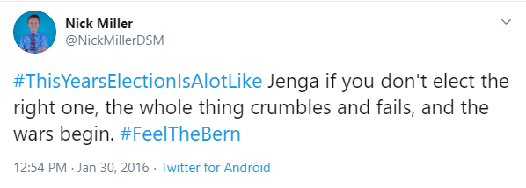

- In 2016, Bernie Sanders was campaigning in Iowa on a single-payer health care plan that did away with private health insurance and raised taxes

  - In a Jan. 26, 2016, article, the Northwest Herald reported, “Wooing undecided Iowa voters, Hillary Clinton and Bernie Sanders on Monday night each cast themselves as life-long champions for tackling economic inequality, but offered differing visions for addressing the nation’s problems.

“Sanders, who is riding a burst of enthusiasm in Iowa, reiterated his calls for free tuition at public colleges and universities and implementing a single payer health care system that would cover all Americans, even though he’d raise taxes to pay for the latter proposal.

“‘Yes, we will raise taxes,’ said Sanders, an admission rarely heard in presidential campaigns. ‘We may raise taxes, but we are going to eliminate private health insurance premiums for individuals and businesses.’”

AOC

- In 2018, Nick Miller said that he was “So happy to see” Alexandria Ocasio-Cortez win her primary election for Congress

  - On June 27, 2018, Nick Miller tweeted, “Very disappointed in @NancyPelosi response to @Ocasio2018. Doesn’t think that their @HouseDemocrats leadership needs work. So happy to see @Ocasio2018 win her primary, glad to see new, younger candidates running for office!”

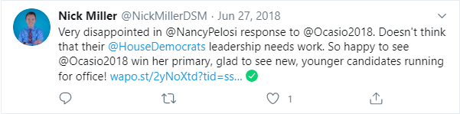

- Alexandria Ocasio-Cortez was a Democratic socialist party candidate that called for the abolition of ICE, single-payer health, tuition-free college and a universal-jobs guarantee

  - In a June 27, 2018, article, the Guardian reported, “Just one year before Alexandria Ocasio-Cortez unseated a powerful 10-term New York congressman to have a chance at becoming the youngest person in Congress, she was mixing cocktails at Flats Fix tacos and tequila bar in Manhattan.

“‘Women like me aren’t supposed to run for office,’ Ocasio-Cortez, a 28-year-old progressive and member of the Democratic socialist party, says in a campaign ad.

“But, at the urging of progressive activists, Ocasio-Cortez not only ran - she won.”

  - According to the same article, “The Democratic socialist ran on issues that remain largely outside of the Democratic mainstream.

“Ocasio-Cortez called for the abolition of the Immigration Customs Enforcement (Ice), an agency that has increasingly become a target of left leaning activists over its treatment of immigrants in its care. She also called for a single-payer healthcare plan that would guarantee healthcare for all Americans, a proposal known as Medicare for All and championed by Sanders. She also called for tuition-free college and a universal-jobs guarantee, under which the federal government would provide a job for every American.”

ABORTION

- Nick Miller in 2017: “#IStandWithPP”

  - On Oct. 7, 2017, Nick Miller tweeted, “There is absolutely NO reason that contraception should not be covered by an employer! #IStandWithPP”

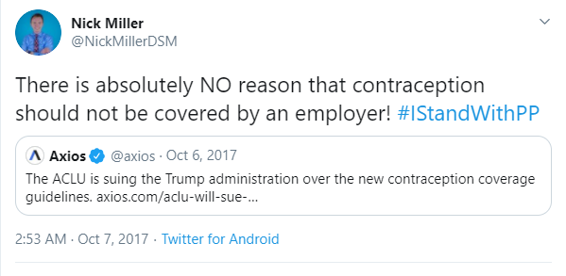

IMMIGRATION

- In 2017, Nick Miller called President Donald Trump’s border wall, “a waste of money and time”

  - On Oct. 23, 2017, Nick Miller tweeted, “Sigh...this is not the answer to immigration. This is a waste of money and time.”

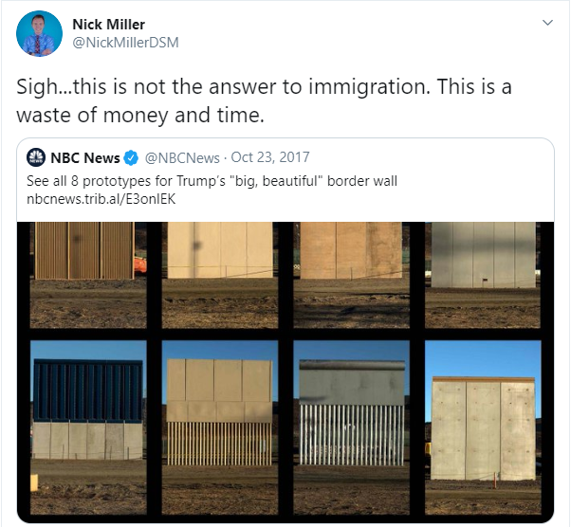

TAXES

- In 2017, Nick Miller said it was “unfortunate” that the U.S. House of Representatives passed the Tax Cuts and Jobs Act, saying it was not going to help the middle-class

  - On Dec. 19, 2017, Nick Miller tweeted, “Unfortunate to see the house pass #TaxCutsandJobsAct because it is not going to help the middle-class. It is only going to the wealthiest Americans. I’m disappointed in the @HouseGOP EXCEPT to those 12 Republicans that voted Nay, I thank you for breaking party lines. Thank you.”

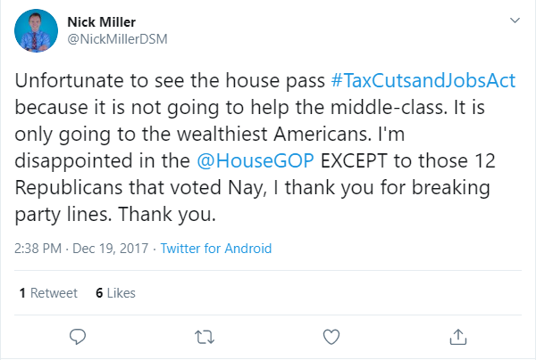

BUSINESSS

- In his campaign for the Iowa House, Nick Miller highlights that at the age of 13, he started his own business, AVL Specialists

  - According to the Nick Miller for Iowa website, “At the age of 13, wanting to earn money but being too young to be hired by anyone, Nick set out to start his own business, AVL Specialists, a DJ company using old speakers and anything he could get his hands on.

“Nick would take advantage of any opportunity that came his way, whether it was a 60-year-old birthday party, girl scout father-daughter dance, or the community block party.”

- Nick Miller says that he worked for AVL Specialists for nearly six years

  - According to Nick Miller’s LinkedIn profile, Miller worked at AVL Specialists from July 2011 to May 2017. According to the profile, “I started a small DJ company in 2011 at the age of 13, by doing small block parties and then providing entertainment services for weddings and dances in excess of 400+ people. I learned first-hand, scheduling, public speaking, and the importance of dealing with clients and making them feel at ease knowing I will take care of everything on my entertainment services.”

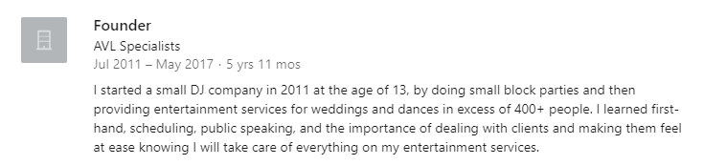

- No businesses named AVL Specialists are found as having been registered with the Iowa Secretary of State

  - According to the Iowa Secretary of State, no business entities in the state are named AVL Specialists.

  - According to the Polk County Recorder of Deeds, no trade name documentation of “AVL Specialists” has been filed with the county.

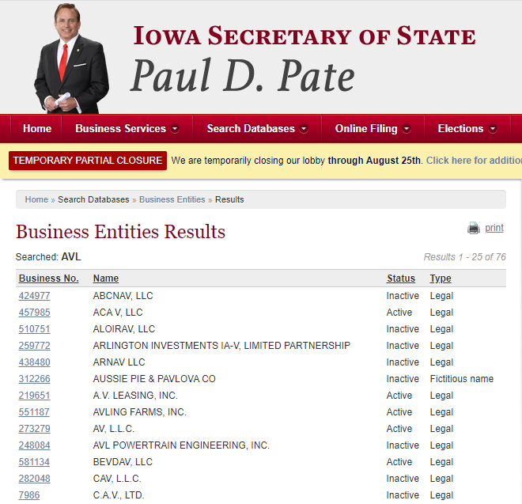

PARENTAL RIGHTS

- In 2017, Nick Miller disagreed that parent’s should monitor their kids’ internet use, saying, “Kids should be allowed privacy. What damage can happen? Why is spying necessary?”

  - On Oct. 23, 2017, Nick Miller tweeted, “Highly disagree. Kids should be allowed privacy. What damage can happen? Why is spying necessary?”

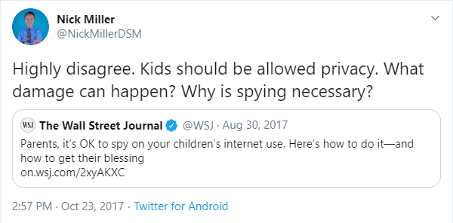

https://twitter.com/NickMillerDSM/status/694322157803864064
https://twitter.com/NickMillerDSM/status/693492507003351040
“Hillary Clinton, Bernie Sanders woo undecided Iowa voters as caucus nears,” Northwest Herald, Jan. 26, 2016
https://twitter.com/NickMillerDSM/status/1012020656454684672
Lauren Gambino, “Alexandria Ocasio-Cortez: who is the new progressive star of the Democrats?” Guardian, June 27, 2018
Lauren Gambino, “Alexandria Ocasio-Cortez: who is the new progressive star of the Democrats?” Guardian, June 27, 2018
https://twitter.com/NickMillerDSM/status/916556970685095936
https://twitter.com/NickMillerDSM/status/922563529659490306
https://twitter.com/NickMillerDSM/status/943204023087370240
Meet Nick, Nick Miller for Iowa website, Accessed Aug. 21, 2020
https://www.linkedin.com/in/nicholas-w-miller-6344649b/
Business Entity Search: AVL Specialists, Iowa Secretary of State, Accessed Aug. 21, 2020
Indexed Records: AVL Specialists, Polk County Recorder of Deeds, Accessed Aug. 21, 2020
https://twitter.com/NickMillerDSM/status/922537515617341442

