JODI GROVER REPORT

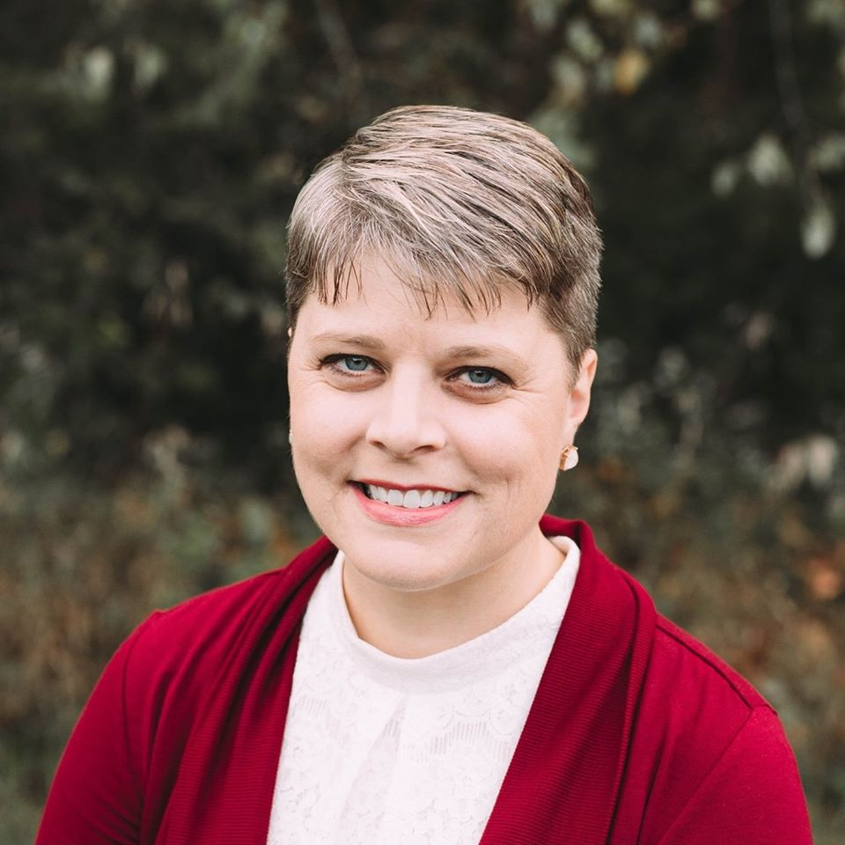

CASCADE STRATEGIES – AUGUST 2020

TABLE OF CONTENTS

TABLE OF CONTENTS 2
BIOGRAPHY 3
TIMELINE 4
JOE BIDEN 5
ELIZABETH WARREN 6
SALARY INCREASES 7
BRIAN SCHOENJAHN 8

BIOGRAPHY

Name: Jodi Lee Grover

Birth: Oct. 3, 1982

Residence: 813 3rd ST. NE Apt. D
Independence, IA 50644

2402 278th St
Rowley, IA 52329

Family: Single

Education: B.A. in Secondary Education, Upper Iowa University
Master’s of Education, Upper Iowa University

Religion: Catholic

Military: None

Professional Experience: Teacher Educator Coordinator--Lead at Upper Iowa University
Clerk for State Senator Brian Schoenjahn

Political Experience: None

TIMELINE

Oct. 3, 1982 Born

2001 Graduated from East Buchanan High School

c. 2003 Earned associates degree from Hawkeye Community College

2007 Began working with the Iowa legislature

2007 Appointed to Generation Iowa Commission

2007 Earned Iowa teaching license

JOE BIDEN

- In the 2020 Iowa Caucus, Jodi Grover supported Joe Biden

  - In a May 21, 2020, article, Bleeding Heartland reported, “Two strong candidates are seeking the Democratic nomination in a top-targeted Iowa House seat.

“Four-term State Representative Bruce Bearinger filed to seek re-election in House district 64 earlier this year but accepted a new position in April. After the June 2 primary, he will formally withdraw, and a special nominating convention will select a replacement Democratic candidate to face Republican Chad Ingels.”

  - According to the same article, “Bushaw was a precinct captain for Pete Buttigieg before the Iowa caucuses, while Grover supported Joe Biden. She even introduced the former vice president at an event in Independence. Buttigieg and Biden did well in the Buchanan County precincts, while Buttigieg won more delegates in the Fayette County portion.”

- In the 2008 Democratic Party primary election, Jodi Grover said that admired that Sen. Joe Biden was specific, but also believed that Hillary Clinton offered experience

  - In a Dec. 30, 2007, article, the Waterloo Courier reported, “Experience and change are qualities often touted by presidential candidates. But these standards aren’t sufficient for picking the nation's next president in U.S. Sen. Joe Biden’s book.

“‘Experience is not enough. Judgment matters,’ Biden said. ‘It’s about action.’

“The Democrat from Delaware, who is seeking the U.S. presidency, spoke Saturday morning at Bill’s Pizza & Smokehouse in Independence. More than 100 people turned out for the caucus count-down event with Biden and the Buchanan County Democrats.”

  - According to the same article, “Jodi Grover, 25, of Rowley, remained undecided moments after Biden’s presentation. She admires that Sen. Biden is specific but also believes U.S. Sen. Hillary Clinton offers experience.

“‘He actually gives concrete examples,’ Grover said. ‘Not just pie in the sky.’”

ELIZABETH WARREN

- In 2019, Jodi Glover made a $5.00 contribution to Elizabeth Warren for President

  - According to the Federal Election Commission, on Jan. 8, 2019, Jodi Grover of Rowley, IA made a $5.00 contribution to Warren for President, Inc.

- Elizabeth Warren supports moving American into full Medicare for All

  - According to the Warren Democrats website (ElizabethWarren.com), “My plan for health care reverses the Trump Administration’s sabotage of our health care, allows everyone in America to choose a Medicare for All option for little or no cost, and cuts costs for families before moving us into full Medicare for All - all in my first term. Add your name if you agree: We need Medicare for All.”

- Elizabeth Warren: “We need a Green New Deal -- and we need it now”

  - According to the Warren Democrats website (ElizabethWarren.com), “The world’s leading experts have long known that climate change is man-made, and we are running out of time. We already see its effects everyday -- record floods, terrifying wildfires, devastating hurricanes -- in events that cost lives and cause billions of dollars in damage, and that disproportionately impact our most vulnerable communities.

“But right now, Washington refuses to lift a finger without permission from the fossil fuel industry. That’s dangerous and it’s wrong. We need a government that makes different choices -- a government that will stop handing out enormous tax giveaways to big oil companies, and stop refusing to invest in our children’s and grandchildren’s futures.

“This is a crisis. We need bold, aggressive action. We need a Green New Deal -- and we need it now. Elizabeth is proud to be an original cosponsor of Senator Ed Markey and Rep. Alexandria Ocasio-Cortez’s Green New Deal resolution, which commits the United States to a ten-year mobilization to achieve domestic net-zero emissions by 2030. It provides the framework for an ambitious effort to transform our economy and save our planet.”

SALARY INCREASES

- Jodi Grover clerked in the Iowa Senate for Senator Brian Schoenjahn

  - According to the Jodi Grover for Iowa House website, “Grover is a Teacher Educator Coordinator--Lead at Upper Iowa University where she oversees the teacher education program in Fayette ​and regional center programs in Des Moines, Waterloo, and Bettendorf. Jodi is a board member of the Iowa Association of Colleges for Teacher Education and clerked in the Iowa Senate for Senator Brian Schoenjahn. She is a member of the Rosary Society, Catholic Daughters, and is a Lector at the St. John’s Catholic Church in Independence. Additionally, Jodi volunteers as a bell ringer for the Buchanan County Salvation Army.”

- In the ten years that Jodi Grover worked for the Iowa State Senate, her bi-weekly salary increased three times, a total increase of more than 23 percent

  - According to the Iowa Legislature’s State Employee Salary Book, Jodi Grover was paid the following bi-weekly salaries from the Iowa State Senate, an increase of 23.56 percent.

Year | Bi-Weekly Salary | Total Salary
2007 | $103.92 | $8,171.28
2008 | $111.84 | $7,961.04
2009 | $111.84 | $8,499.84
2010 | $111.84 | $5,368.32
2011 | $111.84 | $7,605.12
2012 | $120.00 | $7,083.20
2013 | $120.00 | $7,800.00
2014 | $120.00 | $7,320.00
2015 | $120.00 | $7,800.00
2016 | $128.40 | $7,724.96

BRIAN SCHOENJAHN

- Jodi Grover clerked in the Iowa Senate for Senator Brian Schoenjahn

  - According to the Jodi Grover for Iowa House website, “Grover is a Teacher Educator Coordinator--Lead at Upper Iowa University where she oversees the teacher education program in Fayette ​and regional center programs in Des Moines, Waterloo, and Bettendorf. Jodi is a board member of the Iowa Association of Colleges for Teacher Education and clerked in the Iowa Senate for Senator Brian Schoenjahn. She is a member of the Rosary Society, Catholic Daughters, and is a Lector at the St. John’s Catholic Church in Independence. Additionally, Jodi volunteers as a bell ringer for the Buchanan County Salvation Army.”

- In 2016, the Iowa Legislature proposed a higher education budget target that could hike tuition at the state’s three public universities and 15 community colleges; State Senator Brian Schoenjahn (Co-chairman of the Iowa Legislature’s Education Appropriations subcommittee): “We’re looking at tuition increases all over the place”

  - In an April 14, 2016, article, the Times-Republican reported, “The Iowa Legislature’s proposed higher education budget target could hike tuition at the state’s three public universities and 15 community colleges this fall.

“Lawmakers have agreed to give a nearly $4.9 million increase for public higher education in the 2016 to 2017 fiscal year budget, the Iowa City Press-Citizen reports. But the proposed target is more than $3 million less than the minimum that the Iowa Board of Regents says it needs to keep resident undergraduate tuition the same at the University of Northern Iowa and Iowa State University.

“The University of Iowa’s base tuition will already increase by $100 per semester starting in the fall, but the budget target could mean another increase.

“‘We’re looking at tuition increases all over the place,’ said Sen. Brian Schoenjahn, D-Arlington, co-chairman of the Iowa Legislature’s Education Appropriations subcommittee.

“Schoenjahn and his co-chairman, Rep. Cecil Dolecheck, R-Mount Ayr, said they agreed on the higher education numbers for the ‘tight budget’ year.”

- A week later, the Iowa Senate passed a $1 billion higher education budget measure that provided a slight funding increase, but was probably not enough, however, to head off the prospects for tuition increases and cutbacks at Iowa’s public universities and community colleges

  - In an April 21, 2016, article, the Tribune reported, “The Iowa Senate passed a $1 billion higher education budget measure Tuesday that provided a slight funding increase. It’s probably not enough, however, to head off the prospects for tuition increases and cutbacks at Iowa’s public universities and community colleges.

“‘We have to do better,’ Sen. Brian Schoenjahn, D-Arlington, told his Senate colleagues who voted 27-23 to approve a fiscal 2017 spending plan that provided a $6.3 million increase to regent universities and a $3 million boost to Iowa’s 15 community colleges that were a fraction of the new money they requested. The overall budget increase would provide an extra $1.3 million for the University of Iowa, $2.2 million for Iowa State University and $2.78 million for the University of Northern Iowa, he noted.

“‘We came to a bipartisan agreement, but it’s not enough. This basically is a status quo budget,’ said Schoenjahn, in lamented a joint spending target agreed to with majority House Republicans that probably will usher in tuition increases, more adjunct professors and tougher entrance standards at state universities that asked for a $26 million increase.”

- In July 2016, the Iowa Board of Regents approved a $250 tuition increase to try to offset funds which were not approved by the Iowa Legislature

  - According to a July 18, 2016, WHO report, “The Iowa Board of Regents has approved a tuition increase to try to offset funds which were not approved by the Iowa Legislature.

“Regent Larry McKibben proposed a $250 increase instead of $300, which was approved unanimously. Regent Chair Bruce Rastetter said he talked with University Presidents, and they said they could operate with that increase.

“Several Regents and ISU President Steven Leath all said the schools need to find a better, more predictable model to help the schools do their budgets.”

- In 2016, Brian Schoenjahn lost his re-election campaign 60 percent to 40 percent

  - In a Nov. 10, 2016, article, the Waterloo Courier reported, “Sen. Brian Schoenjahn, D-Arlington, first elected in 2004, lost to Republican challenger Craig Johnson, who previously lost a close bid for an Iowa House seat in 2014.

“His victory Tuesday night left him ‘thrilled.’

“Johnson won with 18,605 votes, or 59.9 percent, according to unofficial results. Schoenjahn received 12,408 votes, or 40 percent. There were 29 write-in votes.

“‘What went on yesterday was amazing. The people spoke, and we’re ready to go to work,’ Johnson said. ‘This is just amazing.’

“Like Edler, Johnson is ready to get to work. Johnson, executive director of Heartland Acres in Independence, said his top priorities will be jobs, education and the budget.

“Schoenjahn said it has been ‘one of the great honors of my life to be your voice’ in the Senate. He offered his congratulations to Johnson and also offered to do everything he could to make the transition easier.”

Laura Belin, “Democrats Travis Bushaw, Jodi Grover running in Iowa House district 64,” Bleeding Heartland, May 21, 2020
Laura Belin, “Democrats Travis Bushaw, Jodi Grover running in Iowa House district 64,” Bleeding Heartland, May 21, 2020
Karen Heinselman, “Biden sees judgment as strong suit,” Waterloo Courier, Dec. 30, 2007
Karen Heinselman, “Biden sees judgment as strong suit,” Waterloo Courier, Dec. 30, 2007
Individual Donor Search: Jodi Glover, Federal Election Commission, Accessed July 15, 2020
“My First Term Plan For Reducing Health Care Costs In America And Transitioning To Medicare For All,” Warren Democrats, Accessed July 9, 2020
“Fight For a Green New Deal,” Warren Democrats, Accessed July 9, 2020
About Jodi, Jodi Grover for Iowa House website, Accessed Aug. 10, 2020
State Employee Salary Book: Jodi Grover, Iowa Legislature, Accessed Aug. 6, 2020
About Jodi, Jodi Grover for Iowa House website, Accessed Aug. 10, 2020
“Tuition could rise at Iowa universities, community colleges,” Times-Republican, Aug. 12, 2020
Rod Boshart, “Modest boost for higher ed endorsed,” Tribune, April 21, 2016
Roger Riley, “Iowa Board of Regents Approve $250 Tuition Increase,” WHO, July 18, 2016
Christina Crippes, “GOP success in Iowa Senate helped by northeast Iowa races,” Waterloo Courier, Nov. 10, 2016

