SHELLY STOTTS REPORT

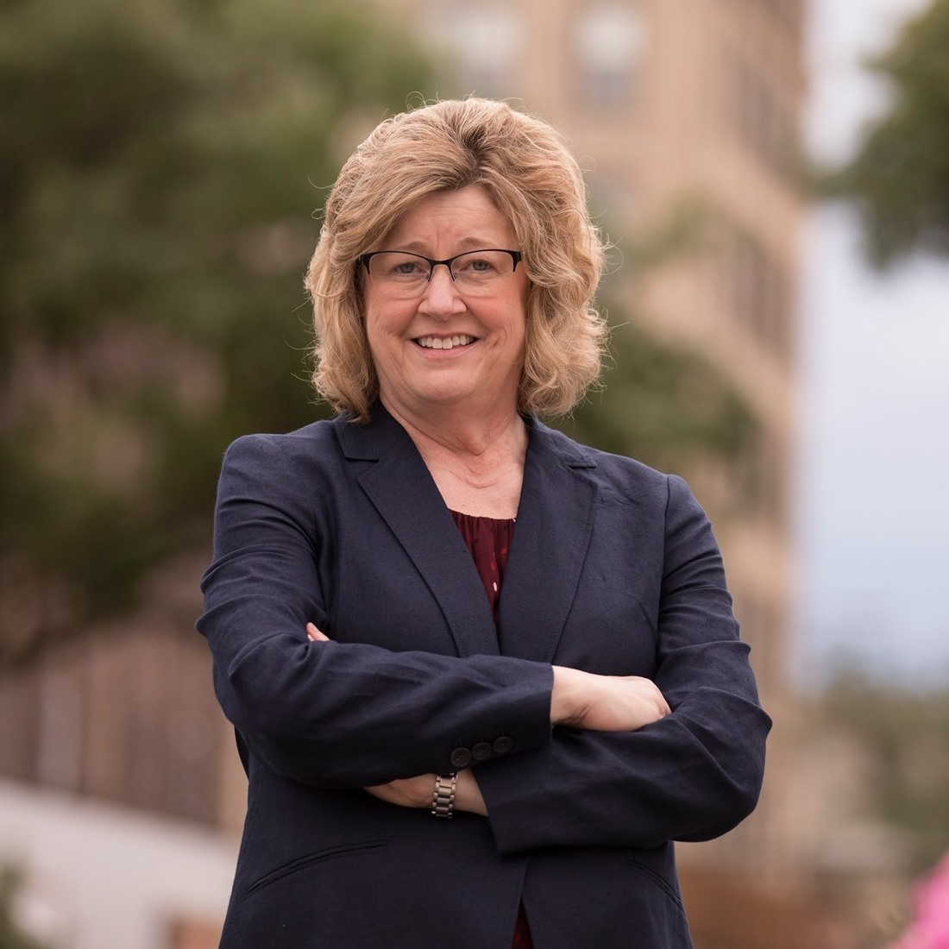

CASCADE STRATEGIES – AUGUST 2020
TABLE OF CONTENTS

TABLE OF CONTENTS 2
BIOGRAPHY 3
TIMELINE 4
GUN CONTROL 5
ABORTION 6
ENDORSEMENTS 7
TAXES 8

BIOGRAPHY

Name: Shelly Lynn Stotts

Birth: Nov. 13, 1961

Residence: 533 S Delaware St
Boone, IA 50036

Family: Widowed (Jeff); 2 Daughters: Kaitlyn and Allison. Has 2 grandchildren: Addison (4) and Ava (3).

Education: Bachelors, Elementary Education, Iowa State University.
Masters, School Guidance, Iowa State University

Religion: Trinity Lutheran Church

Military: None

Professional Experience: Math Teacher, Boone Middle School

Political Experience: Candidate, Iowa State Senate, District 24, 2012.

TIMELINE

Nov. 13, 1961 Born

1980 Graduated from Boone High School

1984 Completed Undergrad in Elementary Education at Iowa State University

1987 Earned Masters in School Guidance from Iowa State

Began teaching.

Feb. 24, 2000 Husband Jeff killed in a plane crash

2012 Candidate, Iowa State Senate, District 24

GUN CONTROL

- Shelly Stotts supports gun-buy-back legislation and the banning of high capacity magazine clips and semiautomatic weapons

  - In her Vote411 Voter Guide questionnaire, when asked what steps should be taken to curb gun violence in Iowa, Shelly Stotts answered, “I come from a family of hunters and sportsmen. Hunting pheasants was a family favorite. But, I never heard complaints about the guns my husband or Dad used. Now, however, certain protections are needed to curb the countless deaths that are a result of gun violence in the United States. Twenty years of school shootings, night club and shopping center shootings, and the terrible shootings in Las Vegas are more than enough. As a teacher, I have heard 5th and 6th graders express their worry about what could happen at their school. I support gun-buy-back legislation and the banning of high capacity magazine clips and semiautomatic weapons.”

ABORTION

- Shelly Stotts said that she will be an advocate for a woman’s right to choose

  - In her Vote411 Voter Guide questionnaire, when asked what steps she would take to address inequalities facing women in Iowa, Shelly Stotts answered, “I will be a strong advocate for pay equity and a woman’s right to choose. With many women as the head of the household and /or the only income source for a family, we must ensure that all workers make living wages that aren’t dependent on gender. I will also support families through programs that assist with the costs of childcare and affordable health insurance. Finally, it is senseless that we continue to question a woman’s right to make her own health care decisions. Iowa law should not single out one gender, the State constitution should represent all people.”

ENDORSEMENTS

- Shelly Stotts has been endorsed by the Iowa chapter of the Sierra Club

  - According to the Iowa Chapter of the Sierra Club, Shelly Stotts has been endorsed by the organization. According to the Sierra Club’s website, “Every election cycle, the Iowa Chapter of the Sierra Club endorses candidates running for public office. The candidates that the Sierra Club endorses are selected based on their support of the critical environmental issues facing Iowans such as clean water, renewable energy, voter access to the polls, and protection of the bottle deposit law. They are leaders who truly care about public policy and its effect on the citizens of Iowa. True leadership means dealing with the problems the state faces. Being a leader requires courage, vision, and an interest in the future.”

- The Iowa Chapter of the Sierra Club pushed for the Green New Deal as part of Covid-19 recovery

  - In a May 7, 2020, Facebook post in response to an article regarding a Covid-19 relief package, the Iowa Chapter of the Sierra Club posted, “The Rooseveltian response should be a green and just recovery. In other words, America needs the Green New Deal! #GreenNewDeal #GND #GreenRecovery”

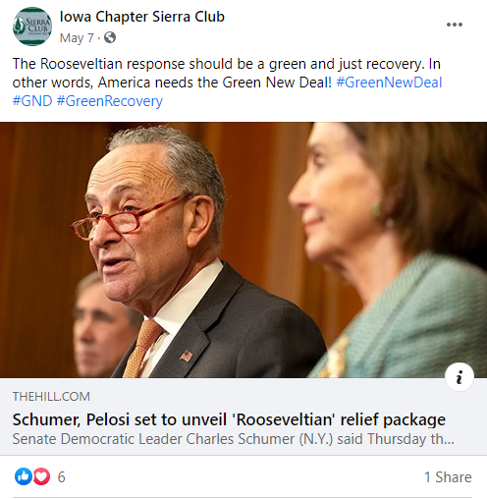

TAXES

- Shelly Stotts says that she would support revisiting the corporate tax rate and taxing based on the types of businesses filing taxes, saying local small businesses, bigger state-based businesses and huge, out-of-state corporations should have different tax rates

  - In her Vote411 Voter Guide questionnaire, when asked if she would emphasize reforming tax policies or addressing income inequality to build a strong economy in Iowa, Shelly Stotts answered, “The minimum wage has not changed for over ten years. However, the costs of basic needs - food, housing, transportation, medications, clothing etc. - have increased with little regard to income. Most elected officials could not survive on the current minimum wage of $7.25 per hour, yet they expect their constituents to. People want to work, but they need to earn a living wage. It’s time we raised the minimum wage in Iowa. In reference to taxes, I would support revisiting the corporate tax rate and taxing based on the types of businesses filing taxes. For example, local small businesses, bigger state-based businesses and huge, out-of-state corporations should have different tax rates.”

Shelly Stotts Vote411 Voter Guide, Accessed May 29, 2020
Shelly Stotts Vote411 Voter Guide, Accessed May 29, 2020
2020 Candidate Endorsements, Sierra Club – Iowa Chapter, Accessed Aug. 25, 2020
https://www.facebook.com/IowaSierraClub/posts/3080391565352519
Shelly Stotts Vote411 Voter Guide, Accessed May 29, 2020

